CDTA COMMITTEE AGENDA

Performance Oversight Committee

May 24, 2017

Start Time: 12:00 pm; Anticipated End Time: 2:30 pm

110 Watervliet Avenue

Committee Item Responsibility

Call to Order David Stackrow

Ascertain Quorum David Stackrow

Agenda Approval David Stackrow

Approve Minutes of April 19, 2017 David Stackrow

Consent Agenda Items
- Approve Contract for Sand/Gravel Separator Maintenance (5 minutes) Stacy Sansky
- Approve Contract for Window Washing (5 minutes) Stacy Sansky
- Approve Contract for Trash/Recycling Services (5 minutes) Stacy Sansky
- Approve Contract for Camera Installations (5 minutes) Stacy Sansky
- Approve Purchase of Two Articulated Buses (5 minutes) Stacy Sansky
- Approve RRS Parking Garage Emergency Repairs (5 minutes) Stacy Sansky
- Approve Contract for RRS Newsstand Concessions (5 minutes) Stacy Sansky
- Approve Contract for RRS Food Concessions (5 minutes) Stacy Sansky
- Approve Contract for Insurance Brokerage Services (5 minutes) Stacy Sansky
- Accept 10% State Share of Federal Grants (5 minutes) Bridget Beelen

Audit Committee
- Internal Audit Monthly Report (5 minutes) * Sarah Matrose
- Approve FYE 2017 Audit Draft (20 minutes) * Mike Collins

Investment Committee
- Update on Committee Activities / Reports (5 minutes) * David Stackrow

Administrative Discussion Items
- Workspace Safety Annual Report (10 minutes) Rick Vines
- Risk Management & Workers’ Compensation Quarterly Report (5 minutes) Amanda Avery
- Monthly Management Report (10 minutes) * Mike Collins
- Monthly Non-Financial Report (10 minutes) * Chris Desany

Executive Session
- Pending Litigation Quarterly Report (5 minutes) Amanda Avery
- Security Update Monthly Report (5 minutes) Rick Vines

For the Good of the Order

Next Meeting Date: June 21, 2017

Adjourn David Stackrow

* Indicates Material (Or Additional Material) Will Be Provided at Meeting


Capital District Transportation Authority
Performance Oversight Committee
Meeting Minutes – April 19, 2017 at 12:00 pm at 110 Watervliet Avenue

In Attendance
Art Young (Acting Chair), Joe Spairana, Corey Bixby, Carm Basile (CEO), Christopher Desany (CSL), Mike Collins, Fred Gilliam, Lance Zarcone, Amanda Avery, Stacy Sansky, Jonathan Scherzer, Phil Parella, Mark Wos, Sarah Matrose, Jaime Watson, Rick Vines, Thomas Guggisberg, Kathy Colbert.

Meeting Purpose: Regular meeting of the Performance Oversight Committee

It was noted that a quorum was present. The minutes from the March 22, 2017 meeting were reviewed and approved.

Consent Agenda Items

Approve Contract for Scheduling Software Maintenance
HASTUS software is used throughout the agency for fixed route scheduling, run cutting, work optimization, mapping, stop information displays, trip planning, stop/route/network development, and customer comment tracking. Upon original system acceptance in 2000, CDTA entered into a contract for support and maintenance. This agreement is now due for renewal based on terms that include options to cover the expected future life of the hardware and software of the system. This recommendation for a sole source renewal of the HASTUS system maintenance agreement is based its proprietary nature, which prevents us from pursuing an independent means to cost effectively support the existing system through another vendor.

The Committee recommends awarding a one-year maintenance contract to GIRO of Montréal, Québec, Canada for an amount of $68,590.

Approve Contract for Fixed Camera Upgrades
In 2010, CDTA implemented our fixed camera system which was competitively procured and provided by March Networks. Due to the age of certain components and to ensure operating availability of cameras, Integrated Video Solutions, LLC (IVS) was contracted work with staff and complete a site survey at all five locations, and identify proposed improvements. With this project, we intend to replace or repair cameras that are no longer functioning properly, install new cameras that will allow for viewing areas that are not currently covered by the system, and upgrade all facilities to run the same version of the March video recording system. IVS also provided pricing for professional services to engage in daily monitoring of the system. This includes remote monitoring of the system’s operation and availability, user management, warranty processing, managing the system vendor and reporting on system issues.

The Committee recommends awarding a sole source contract to Integrated Video Solutions, LLC of Chester, NJ for fixed video system maintenance and repair for a total value of $97,000.

The Committee recommends awarding five, one-year sole source monitoring contract options to Integrated Video Solutions, LLC of Chester, NJ for a total amount of $60,000.

Approve Work for Water Main Repair
On January 15th, 2017, it was noted by a CDTA night foreman that there was water coming out of the ground near the supervisors parking area. The City of Albany Public Water Department was called to investigate. Their determination was that one of the main water line feeds to 110 Watervliet Ave. was the source of the leak. Taub Plumbing, a licensed contractor, was called to make the emergency repair. Permits from the city were required and issued prior to commencing any work. Three leaks were located and repaired. Final asphalt coasting will be applied once the weather permits and the asphalt plants re-open for the season.

Therefore, the Committee is recommending that the total cost associated with this emergency work be paid to the contractors in a total amount of $63,000.

Approve Contract for Shelter Installations
CDTA has a robust shelter maintenance and replacement program. Shelters may be replaced due to damage beyond repair, addition of new stop locations (or upgrading an existing location from a sign to a shelter), or merely because the shelter is old and is showing signs of excessive wear. In February, the Board awarded a contract for the fabrication and delivery of bus shelters. As discussed at that time, staff indicated that it would be returning to the Committee to make a recommendation for the installation of those shelters. CDTA issued an Invitation for Bid to install all concrete pads, shelters, benches and possible concrete work such as standing pads and curbs. We received two proposals. HMA Contracting Corp submitted the lowest price and has been qualified for the work. CDTA has worked with the project manager from HMA in the past as has been very satisfied.

The Committee recommends awarding a five-year contract for the installation of shelters and shelter amenities to HMA Contracting Corp. of Mechanicville, NY in an amount not to exceed $1,775,000.

Approve Contract for RRS Deck Repair
Over time, the concrete topping of the RRS parking deck began cracking in many places across the deck and was allowing water to penetrate to the lower levels. The solution to remedy the situation was to apply a membrane over the entire top deck to stop the infiltration. After the installation, an annual maintenance program was implemented to maintain the membrane, but as it became closer to the end of its useful life, ongoing repairs have become cost prohibitive. A design team lead by Clough Harbour and Associates was assembled to assess the best and most cost-effective way to stop the infiltration of water into the garage. The new design minimizes the use of sidewalks, and increases the parking capacity of the deck by 50 spaces. An Invitation For Bid (IFB) was issued for the installation of a new waterproofing membrane, removal and replacement of sidewalks, replacement of corroded conduit and wiring, refurbishment of the light poles with LED lighting, and installation of additional floor drains. The IFB outlined specific unit cost items, estimated quantities, as well as specific design details. Twenty vendors downloaded the IFB and four bids were received. Staff and the design consultant reviewed the bid results. The bids ranged from $2.54M to $4.27M. The engineer’s construction estimate was $3.98M.

The Committee recommends awarding a two-year contract to Patterson-Stevens of Tonawanda, NY for RRS deck repair in the amount of $2,543,625. Staff is recommending a 20% contingency of $508,725 for a total amount not to exceed $3,052,350.

Approve Purchase of Fixed Route Buses
The current fleet replacement plan calls for annual vehicle purchases and disposal of vehicles that have reached the end of their useful life. Requests for Proposals were issued for 40’ diesel buses in 2016. This contract was awarded to Gillig.

The Committee recommends approving the purchase of twelve 40’ buses from Gillig, LLC of Hayward, CA for a cost of $463,040 per vehicle plus an additional $5,550 for extended warranty on engine. The total cost is $5,623,080.

Approve Purchase of STAR Buses
The current fleet replacement plan calls for annual vehicle purchases and disposal of vehicles that have reached the end of their useful life. Requests for Proposals were issued for 40’ diesel buses in 2016. This contract was awarded to Shepard Brothers.

The Committee recommends approving the purchase of six paratransit vehicles from Shepard Brothers of Canandaigua, NY for a cost of $82,377 per vehicle plus an additional $10,000 for radio communication equipment. The total cost is $554,263.

Approve Contract with CDOT for Motor Coaches
The current fleet replacement plan calls for annual vehicle purchases and disposal of vehicles that have reached the end of their useful life. CDTA is utilizing the “piggy back” option to purchase commuter buses from the Connecticut Department of Transportation (ConnDOT) contract. Using a piggy back procurement allows CDTA to save time and money for small quantity purchases. A Request for Proposals (RFP) was issued by ConnDOT for motor coaches. Staff has requested options against this contract that would allow for a vehicle purchase and meet all federal requirements. ConnDOT has granted the request for CDTA to purchase three buses under this contract. CDTA will execute our own agreement with MCI for the actual purchase.

The Committee recommends approval to execute a contract with Motor Coach Industries of Schaumberg, IL for the purchase of three NX vehicles for a cost of $495,107 per vehicle. The total cost is $1,485,321.

Annual Review and Approval of Procurement Manual
The Public Authorities Law requires that authorities review their procurement guidelines on an annual basis. Based on a staff review of the manual, there are no substantive changes being recommended this year; save minor updates that are outlined below:

- Revise Table of Contents to eliminate formatting issues
- Removal of term “Purchasing Department” whenever used and replaced with “Procurement Department”
- Inclusion of updated “Petty Cash Policy”
- Other minor changes to style that do not alter content

The Procurement Manual was provided for review.

The Committee recommends approval of the Procurement Manual.

Audit Committee Items

Internal Audit Monthly Report
Sarah Matrose gave the internal audit monthly report. Work in progress included the accounts receivable audit and risk assessment interviews. The audit plan was provided for review.

The Committee recommends approving the proposed Three-Year Audit Plan.

It was noted that Lumsden and McCormick began their fiscal year-end audit.

Investment Committee Items

Annual Review and Approval of Investment Policy
The New York Public Authorities Law Article 9, Title 7 annually requires public authorities to review and approve their Investment Policy. This policy details the operative policy for investing, monitoring and reporting of funds for CDTA. We have proposed six minor changes to the investment policy. These changes will improve consistency and clarity of terms and tighten controls for collateral. The draft policy illustrates what is recommended for removal (crossed out), and new language which is underlined. The revised 2017 Investment Policy was attached for review. General Counsel has reviewed our investment policy and the law for any additional changes and does not recommend any further modifications.

The Committee recommends approving the Investment Policy.

The Hugh Johnson report was provided to the Committee.

Administrative Discussion Items

RRS Concessions Update
Chris Desany gave an update on the RRS concession contracts. In an effort to serve the customers at the Rensselaer Rail station, two concessions were established: a newsstand and a food service. The original leases for both concessions have expired. A Request For Proposals was issued and criteria were based upon cost effectiveness, experience, qualifications and DBE/MWBE participation. As the solicitation was issued, Procurement, Marketing and Facilities all conducted outreach to seek as many proposals as possible. Three proposals were received for the newsstand and two for the food concession. After review of all the proposals by an evaluation committee, it was decided that both incumbents (Friar Tuck for the newsstand and The Coffee Beanery for the food concession) provided the best options. The minimum guaranteed rent for the newsstand is $42,000, and the food concession is $80,000 (with additional percentages if minimum revenue goals are met). Both have the possibility of additional revenue if certain sales goals are met each year, and the term will be 5 years, with five one-year renewal options.

Monthly Management (financial) Report
Mike Collins gave the monthly management report. Mortgage recording tax is under budget by 32% for the month, but we exceeded budget by 1% for year end. Customer fares for the year exceeded budget for the first time in several years. Wages were over budget due to over time and unbudgeted service. Workers compensation was over budget by 18% for the year due to several loss of use awards. Professional services were 13% over budget for the year, and professional services and advertising were also over budget for the year. Purchased transportation finished $105k under budget for the year. We finished the year 1% over budget in revenue, and almost even for expenses. We are in a satisfactory cash flow position at this time.

Monthly Non-Financial (performance) Report
Chris Desany gave the monthly non-financial report. Total ridership was down 3% for the month and 1% for the year. On time performance was 70% and there were zero PMI’s not on time. Missed trips were at 62 this month. MDBSI was at 14,589. Scheduled work was at 83%. There were 34 preventable and 36 non-preventable accidents, and 96% of customer complaints were closed within 10 days. Website page views were at 1,041,814.

Year-End Non-Financial (performance) Report
Chris Desany gave the year end non-financial report. Total ridership was down for the first time in 6 years (1%). STAR ridership dipped as well. PMI’s not on time went in the right direction, even when the number of PMI’s completed increased by 3%. Preventable and non-preventable accidents increased this year, and a detailed report will be given by the Safety Department in June. Year-end comments decreased, probably as a result of the more robust website and comment forms. Web page activity has been steadily increasing. Total visits increased by 15% and page views increased by 21%. There were 1390 help desk tickets opened last year, and 87% were closed within 7 days.

For The Good of the Order
No items scheduled.

Executive Session
No items scheduled. Mr. Young requested a security update at the Board meeting.

Capital District Transportation Authority
Agenda Action Proposal

Subject: Contract award for sand and gravel separator maintenance to Environmental and Fueling Systems, LLC of Troy, New York.

Committee: Performance Oversight
Committee Meeting Date: May 24, 2017
Board Action Date: May 31, 2017

Background:
The current contract for these services is set to expire and a new one is required.

Purpose:
Each bus division has equipment that separates oil, sand and residue from water that collects in maintenance drains. The water is then discharged into the public water supply system. The equipment requires cleaning twice per year to function properly.

Summary of Proposal:
An Invitation for Bids (IFB) was issued for a vendor to clean sand and gravel separators at each division twice per year. The IFB listed the specific requirements for cleaning as well as locations.

Four (4) vendors downloaded the IFB and one (1) of those submitted bids. This work is specialized with a limited number of vendors in the capital region that perform these services, which led to a single bid being received. Environmental and Fueling Systems, LLC has performed this work previously and staff was satisfied with their performance.

Staff recommends a three-year contract with two optional renewal years be awarded to Environmental and Fueling Systems, LLC of Troy NY for maintenance of the sand and gravel separators for an annual cost of $59,180. Upon Board approval, the contract will be executed immediately.

Financial Summary and Source of Funds:
The estimated five-year contract value is $295,900.
Funding for this maintenance will be included in the appropriate operating budget starting in FY2018.

Prepared by:
Stacy Sansky, Director of Procurement

Project Manager:
Mark Wos, Director of Facilities

To: Chairman, Performance Oversight Committee
Members, Performance Oversight Committee
Chris Desany, Vice President of Planning and Infrastructure
Stacy Sansky, Director of Procurement
From: Mark Wos, Director of Facilities
Re: Contract Award for Sand and Gravel Separator
Date: May 24, 2017

Background
At each of the divisions there exists equipment that separates oil, residue and sand from the water that collects in the maintenance area drains before the water is discharged into the public system.

As part of our ongoing maintenance program, CDTA has a contract to have the sand and gravel separators cleaned twice a year.

As this contract is about to expire, CDTA issued an Invitation For Bid for this service. Seven vendors downloaded the bid and one response was received. Environmental and Fueling Systems, LLC of Troy, NY has provided this service in the past, and staff finds them qualified.

Recommendation
At this time, staff recommends a three-year contract with two one-year options for separator cleaning services with Environmental and Fueling Systems, LLC for an annual amount of $59,180.00.

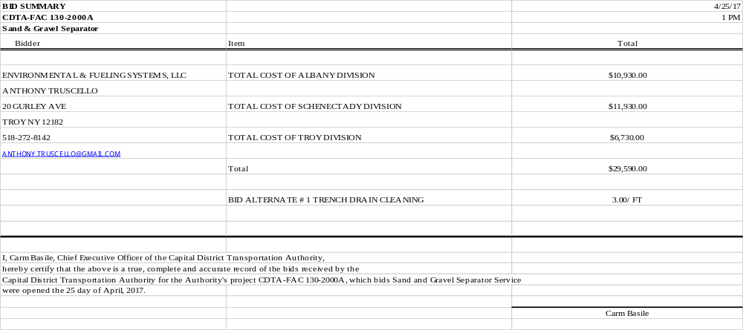

CAPITAL DISTRICT TRANSPORTATION AUTHORITY
Staff Contract Award Certification
1. TYPE OF CONTRACT (check one):
_X___ Construction & Maintenance _ ___ Goods, Commodities & Supplies ____ Bus Purchase
____ Services & Consultants __ __ Transportation & Operational Services

2. TERMS OF PERFORMANCE (check one):
_X _ One-Shot Deal: Complete scope and fixed value
____Fixed Fee For Services: Time and materials - open value
___ Exclusive Purchase Contract: Fixed cost for defined commodity with indefinite quantity
____ Open Purchase Contract: Commitment on specifications and price but no obligation to buy
____ Change Order: Add on to existing contract

3. CONTRACT VALUE:
Total 5-year contract value NTE $295,900 fixed estimated (circle one)

4. PROCUREMENT METHOD (check one):
____ Request for Proposals (RFP) _X___ Invitation for Bids (IFB) ____ Other

5. TYPE OF PROCEDURE USED (check one):
____ Micro Purchases (Purchases up to $2,499.00) ____ Small Purchases ($25,000 up to $$100,000)
__X__ Sealed Bid/Invitation for Bids (IFB) (Over $100,000) ____ Request for Proposals (RFP)
____ Professional Services (Over $25,000) ____ Sole or Single Source (Non-Competitive)

6. SELECTION CRITERION USED:
Number of Proposals/Bids Solicited #_4______ or Advertised
Number of Proposals/Bids Received #_1_______

Attach Summary of Bids/Proposals

- Disadvantaged/Minority Women’s Business Enterprise (D/MWBE) involvement
Are there known D/MWBEs that provide this good or service? Yes No
Number of D/MWBEs bidding/proposing ____0______
D/MWBE Certification on file? Yes No Not Applicable
Number of D/MWBE Subcontractors _____0_____

8. LEGAL NAME and ADDRESS OF CONTRACTOR/VENDOR: _Environmental & Fueling Systems, LLC
_20 Gurley Ave
_Troy, NY 12182
9. SOURCE OF FUNDS: ___ __Appropriate Operating Plan for Each Fiscal Year_______________________________________

10. COMPLIANCE WITH STATE AND FEDERAL RULES:
Non-Collusion Affidavit of Bidder (Yes, No, N/A)
Disclosure & Certificate of Prior Non-Responsibility Determinations (Yes, No, N/A)
Disclosure of Contacts (only RFPs) (Yes, No, N/A)
Certification with FTA’s Bus Testing Requirements (Yes, No, N/A)

11. RESPONSIBLE STAFF CERTIFIES THE INTEGRITY OF THIS PROCUREMENT/CONTRACT:

__Stacy Sansky, Director of Procurement_____ DATED: __May 15, 2017________________________
Capital District Transportation Authority
Agenda Action Proposal

Subject: Contract award for window washing at the Rensselaer Rail Station to Action Window Cleaning Co., Inc of Rensselaer, New York

Committee: Performance Oversight
Committee Meeting Date: May 24, 2017
Board Action Date: May 31, 2017

Background:
The current contract for window washing is set to expire and a new one is required.

Purpose:
CDTA is committed to maintaining a safe, clean and professional environment at the Rensselaer Rail Station.

Summary of Proposal:
An Invitation for Bids (IFB) was issued for a vendor to perform window washing and dusting of high areas at the Rensselaer Rail Station twice per year.

One bid was received (see attached bid) and the responsible low bid was for $15,610 per year. Per New York State Finance Law, Action Windows (the incumbent) was allowed to submit a bid after reviewing bids received. Action Windows is a division of New York State Industries for the Disabled (NYSID) and is a New York State Preferred Source. Preferred Sources are to be awarded a contract if they can meet “the form, function and utility” of the specification and come within 15% of the low bid (fair market price). The price provided by Action Windows is 5% ($325 per year) higher than the low bid and therefore meets the criteria for award to a Preferred Source. Board approval is required for any contract award to a firm other than the low bidder.

Staff recommends a three-year contract with two optional renewal years be awarded to Action Windows Cleaning Co., Inc (a member of NYSID) of Rensselaer, NY for window washing at the Rensselaer Rail Station for an annual amount not to exceed $15,935. Upon Board approval, the contract will be executed immediately.

Financial Summary and Source of Funds:
The estimated five-year contract value is $79,675.
This contract will be funded in the appropriated annual operating budget starting in FY2018.

Prepared by:
Stacy Sansky, Director of Procurement

Project Manager:
Mark Wos, Director of Facilities

To: Chairman, Performance Oversight Committee
Members, Performance Oversight Committee
Chris Desany, Vice President of Planning and Infrastructure
Stacy Sansky, Director of Procurement
From: Mark Wos, Director of Facilities
Re: Contract Award for RRS Cleaning Services
Date: May 24, 2017

Background
CDTA is committed to maintaining a safe, clean, and professional environment for customers at the Rensselaer Rail Station, and a number of contracts are in place to facilitate these goals. The scope of one of these contracts includes dusting high areas of the station and cleaning the windows twice a year. As this contract is about to expire, an Invitation For Bid was issued for the work. Eight bidders downloaded the bid and two bids were received.

The low bid was received by Tristate Façade Services. However, New York State Office of General Services regulations dictate that we accept a qualified bid for these particular services that is within 15% of the fair market value (in this case, determined by our low bid) if it is provided by a certified preferred source.

New York State Industries for the Disabled (NYSID) subsequently provided a lower bid (less than $300) than the previous low bid. NYSID meets the qualifications and is also the incumbent contractor. They have performed this work satisfactorily for the last five years. NYSID also holds the contracts for general cleaning services at the RRS and Saratoga train stations.

Recommendation
At this time staff recommends a three-year contract with two one-year options with New York State Industries for the Disabled, Inc. for an annual amount of $15,935.00.
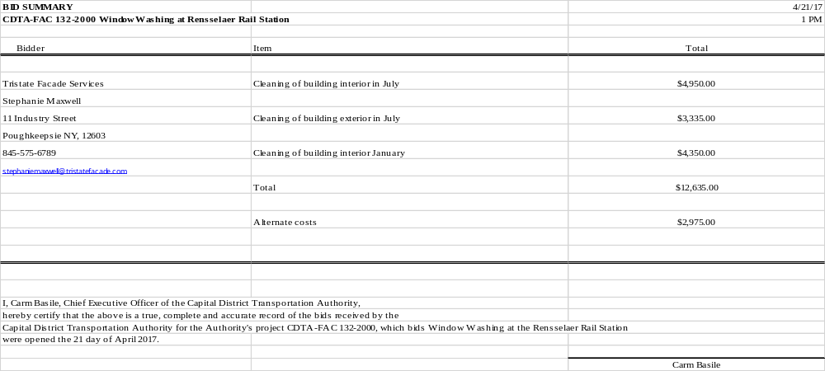

CAPITAL DISTRICT TRANSPORTATION AUTHORITY
Staff Contract Award Certification
1. TYPE OF CONTRACT (check one):
__X_ Construction & Maintenance ____ Goods, Commodities & Supplies ____ Bus Purchase
____ Services & Consultants ____ Transportation & Operational Services

2. TERMS OF PERFORMANCE (check one):
__X_ One-Shot Deal: Complete scope and fixed value
____ Fixed Fee For Services: Time and materials - open value
____ Exclusive Purchase Contract: Fixed cost for defined commodity with indefinite quantity
____ Open Purchase Contract: Commitment on specifications and price but no obligation to buy
____ Change Order: Add on to existing contract

3. CONTRACT VALUE:
_$79,675 (5 year)_______________ fixed estimated (circle one)

4. PROCUREMENT METHOD (check one):
____ Request for Proposals (RFP) ____ Invitation for Bids (IFB) _X___ Other –Preferred Source

5. TYPE OF PROCEDURE USED (check one):
____ Micro Purchases (Purchases up to $2,499.00) ____ Small Purchases ($25,000 up to $$100,000)
____ Sealed Bid/Invitation for Bids (IFB) (Over $100,000) ____ Request for Proposals (RFP)
____ Professional Services (Over $25,000) ____ Sole or Single Source (Non-Competitive)

6. SELECTION CRITERION USED:
Number of Proposals/Bids Solicited #_5______ and Advertised
Number of Proposals/Bids Received #_1_____

Attach Summary of Bids/Proposals-Not Applicable

- Disadvantaged/Minority Women’s Business Enterprise (D/MWBE) involvement
Are there known D?MWBEs that provide this good or service? Yes No
Number of D/MWBEs bidding/proposing _____0_____
D/MWBE Certification on file? Yes No Not Applicable

8. LEGAL NAME and ADDRESS OF CONTRACTOR/VENDOR: New York State Industries for the Disabled 11 Columbia Circle____________________
_Albany, NY 12203___________________
9. SOURCE OF FUNDS: _FY2018-FY2022 Operating Budget_________________________________________

10. COMPLIANCE WITH STATE AND FEDERAL RULES:
Non-Collusion Affidavit of Bidder (Yes, No, N/A)
Disclosure & Certificate of Prior Non-Responsibility Determinations (Yes, No, N/A)
Disclosure of Contacts (only RFPs) (Yes, No, N/A)
Certification with FTA’s Bus Testing Requirements (Yes, No, N/A)

11. RESPONSIBLE STAFF CERTIFIES THE INTEGRITY OF THIS PROCUREMENT/CONTRACT:

_Stacy Sansky, Director of Procurement_____ DATED: __May 15, 2017________________________

Capital District Transportation Authority
Agenda Action Proposal

Subject: Contract award for trash removal and recycling services to County Waste and Recycling Services of Clifton Park, New York

Committee: Performance Oversight
Committee Meeting Date: May 24, 2017
Board Action Date: May 31, 2017

Background:
The current contract for trash & recycling services is set to expire and a new one is required.

Purpose:
CDTA disposes of trash and recycling according to state environmental regulations.

Summary of Proposal:
An Invitation for Bids (IFB) was issued for a vendor to provide weekly trash and recycling pick-up for all three bus divisions and the Rensselaer Rail Station. The IFB listed pick-up frequency requirements as well as reports required for submittal to New York State.

Ten (10) vendors downloaded the IFB and two (2) of those submitted bids. The bid received from County Waste and Recycling Services was the lowest responsive and responsible bid. County Waste has performed this work previously and staff was satisfied with their performance.

Staff recommends a three-year contract with two optional renewal years be awarded to County Waste and Recycling of Clifton Park, NY for trash and recycling pick up for an annual amount not to exceed $117,207. Upon Board approval, the contract will be executed immediately.

Financial Summary and Source of Funds:
The estimated five-year contract value is $586,035
Operating Budgets FY2018 through FY2022

Prepared by:
Stacy Sansky, Director of Procurement

Project Manager:
Mark Wos, Director of Facilities

To: Chairman, Performance Oversight Committee
Members, Performance Oversight Committee
Chris Desany, Vice President of Planning and Infrastructure
Stacy Sansky, Director of Procurement
From: Mark Wos, Director of Facilities
Re: Contract Award for Waste and Recycling Services
Date: May 24, 2017

Background
CDTA maintains a contract to provide weekly pick up of trash and recyclables at all three divisions and the Rensselaer Rail Station. As this contract is about to expire, and Invitation For Bid was issued for these services. 14 vendors downloaded the package, and two vendors responded. County Waste provided the lowest bid, has provided these services in the past, and is qualified to do the work.

Recommendation
At this time staff recommends a three-year contract with two one-year options for trash/recycling services with County Waste and Recycling Services for an annual amount of $117,207.00.

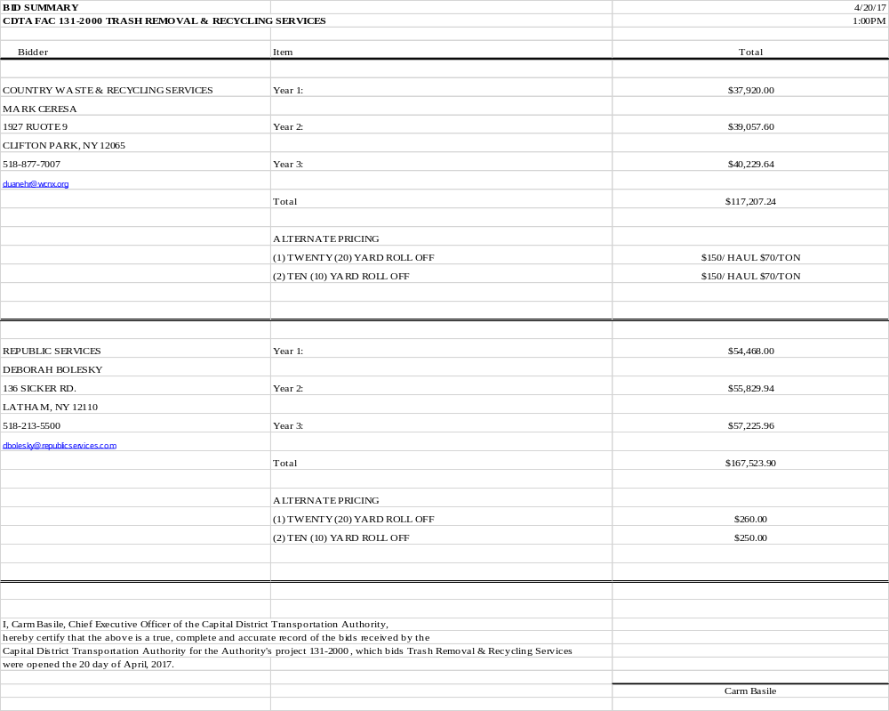
CAPITAL DISTRICT TRANSPORTATION AUTHORITY
Staff Contract Award Certification
1. TYPE OF CONTRACT (check one):
_X___ Construction & Maintenance _ ___ Goods, Commodities & Supplies ____ Bus Purchase
____ Services & Consultants __ __ Transportation & Operational Services

2. TERMS OF PERFORMANCE (check one):
_X _ One-Shot Deal: Complete scope and fixed value
____Fixed Fee For Services: Time and materials - open value
___ Exclusive Purchase Contract: Fixed cost for defined commodity with indefinite quantity
____ Open Purchase Contract: Commitment on specifications and price but no obligation to buy
____ Change Order: Add on to existing contract

3. CONTRACT VALUE:
Total 5-year contract value NTE $586,035 fixed estimated (circle one)

4. PROCUREMENT METHOD (check one):
____ Request for Proposals (RFP) _X___ Invitation for Bids (IFB) ____ Other

5. TYPE OF PROCEDURE USED (check one):
____ Micro Purchases (Purchases up to $2,499.00) ____ Small Purchases ($25,000 up to $$100,000)
__X__ Sealed Bid/Invitation for Bids (IFB) (Over $100,000) ____ Request for Proposals (RFP)
____ Professional Services (Over $25,000) ____ Sole or Single Source (Non-Competitive)

6. SELECTION CRITERION USED:
Number of Proposals/Bids Solicited #_10______ or Advertised
Number of Proposals/Bids Received #_2_______

Attach Summary of Bids/Proposals

- Disadvantaged/Minority Women’s Business Enterprise (D/MWBE) involvement
Are there known D/MWBEs that provide this good or service? Yes No
Number of D/MWBEs bidding/proposing ____0______
D/MWBE Certification on file? Yes No Not Applicable
Number of D/MWBE Subcontractors _____0_____

8. LEGAL NAME and ADDRESS OF CONTRACTOR/VENDOR: _County Waste & Recycling Services________________
_1927 Route 9____________________________ _______
_Clifton Park, NY 12065___________________________
9. SOURCE OF FUNDS: ___ __Appropriate Operating Plan for Each Fiscal Year-FY2018-FY2022_____________________

10. COMPLIANCE WITH STATE AND FEDERAL RULES:
Non-Collusion Affidavit of Bidder (Yes, No, N/A)
Disclosure & Certificate of Prior Non-Responsibility Determinations (Yes, No, N/A)
Disclosure of Contacts (only RFPs) (Yes, No, N/A)
Certification with FTA’s Bus Testing Requirements (Yes, No, N/A)

11. RESPONSIBLE STAFF CERTIFIES THE INTEGRITY OF THIS PROCUREMENT/CONTRACT:

__Stacy Sansky, Director of Procurement_____ DATED: __May 15, 2017________________________
Capital District Transportation Authority
Agenda Action Proposal

Subject: Sole source contract recommendation for bus fleet camera upgrade to March Networks of Ottawa, Canada.

Committee: Performance Oversight
Committee Meeting Date: May 24, 2017
Board Action Date: May 31, 2017

Background:
In 2007 the fixed-route camera system was competitively procured and awarded to March Networks.

Purpose:
The equipment on a portion of the CDTA fleet will no longer be supported and requires an upgrade.

Summary of Proposal:
As stated above, the fixed-route camera system was competitively procured in 2007 with a contract awarded to March Networks. March Networks is phasing out support of the Mobile Digital Video Recorders (MDVR) (of which CDTA has 155 installed) for the Network Video Recorders (NVR). By 2018 CDTA will not be able to purchase repair parts for these MDVR’s. To avoid substantial duplication costs through a new provider and to ensure availability of equipment a sole source contract is required.

Staff recommends a contract be awarded to March Networks of Ottawa, Canada for the purchase of Network Video Recorders at a cost not to exceed $468,485. Upon Board approval, a contract will be executed immediately so that NVR’s can be ordered. Upon receipt of new equipment CDTA staff will complete the installation.

Financial Summary and Source of Funds:
Not to exceed $468,485. This project will be funded through the FY2018 Capital Plan.

Prepared by: Stacy Sansky, Director of Procurement

Project Manager: Lance Zarcone, Director of Maintenance



Memorandum

Date: May 8, 2017

To: Members, Performance Oversight Committee

From: Lance Zarcone, Director of Maintenance

Subject: Sole Source for Network Video Recorder (NVR)

Overview
In 2007, electronic surveillance equipment was introduced to CDTA’s fixed-route bus fleet. The camera systems were competitively procured and awarded to March Networks, Inc. of Ottawa, Canada. CDTA currently has these systems in about 80% of its fixed-route buses. We recently started installing them our paratransit fleet as well. The camera systems have proven to have numerous benefits, including but not limited to: protecting drivers, deterring violence and enhancing passenger safety, reducing liability and improving investigations. There has also been a positive impact on training as well as our relationships with the law enforcement community, who frequently requests footage to help them solve crimes. Over the last two bus builds, CDTA has migrated all Mobile Digital Video Recorders (MDVR) to Network Video Recorders (NVR) to update some of the camera technologies.
CDTA has 155 busses which need the new unit installed. In 2018, these units will no longer be supported by March Networks for repair.
Staff is recommending a sole source contract award to March Networks of Ottawa, Canada to replace all MDVR’s to the most current NVR so that all busses will have the newest state of the art equipment. Staff has reviewed this pricing and finds it to be fair and reasonable in comparison to previous NVR purchases.

The cost of this project is not to exceed $468,485.
CAPITAL DISTRICT TRANSPORTATION AUTHORITY
Staff Contract Award Certification
1. TYPE OF CONTRACT (check one):
__ _ Construction & Maintenance _ _X__ Goods, Commodities & Supplies ____ Bus Purchase
____ Services & Consultants __ __ Transportation & Operational Services

2. TERMS OF PERFORMANCE (check one):
_X _ One-Shot Deal: Complete scope and fixed value
____ Fixed Fee For Services: Time and materials - open value
__ _ Exclusive Purchase Contract: Fixed cost for defined commodity with indefinite quantity
____ Open Purchase Contract: Commitment on specifications and price but no obligation to buy
____ Change Order: Add on to existing contract

3. CONTRACT VALUE:
____$468,485 (NTE) fixed estimated (circle one)

4. PROCUREMENT METHOD (check one):
_ ___ Request for Proposals (RFP) __ __ Invitation for Bids (IFB) _X___ Other

5. TYPE OF PROCEDURE USED (check one):
____ Micro Purchases (Purchases up to $2,499.00) ____ Small Purchases ($25,000 up to $$100,000)
__ _ Sealed Bid/Invitation for Bids (IFB) (Over $100,000) __ __ Request for Proposals (RFP)
____ Professional Services (Over $25,000) __X_ Sole or Single Source (Non-Competitive)

6. SELECTION CRITERION USED:
Number of Proposals/Bids Solicited #__1___ or Advertised
Number of Proposals/Bids Received #__1___

Attach Summary of Bids/Proposals

- Disadvantaged/Minority Women’s Business Enterprise (D/MWBE) involvement
Are there known D/MWBEs that provide this good or service? Yes No
Number of D/MWBEs bidding/proposing _____0_____
D/MWBE Certification on file? Yes No Not Applicable
Was contract awarded to a D/MWBE? Yes 0
Number of D/MWBE Subcontractors _____0_____

8. LEGAL NAME and ADDRESS OF CONTRACTOR/VENDOR: March Networks, Inc.________________________
Suite 500 3455 Peachtree Road NE______________
Atlanta, Georgia 30326______________ _________
9. SOURCE OF FUNDS: _FY2018 Capital Budget__________________________________________________________

10. COMPLIANCE WITH STATE AND FEDERAL RULES:
Non-Collusion Affidavit of Bidder (Yes, No, N/A)
Disclosure & Certificate of Prior Non-Responsibility Determinations (Yes, No, N/A)
Disclosure of Contacts (only RFPs) (Yes, No, N/A)
Certification with FTA’s Bus Testing Requirements (Yes, No, N/A)

11. RESPONSIBLE STAFF CERTIFIES THE INTEGRITY OF THIS PROCUREMENT/CONTRACT:

__Stacy Sansky, Director of Procurement_____ DATED: _May 15, 2017_________
Capital District Transportation Authority
Agenda Action Proposal

Subject: Purchase of two articulated buses for fixed route service from the New Flyer of America, Inc. contract.

Committee: Performance Oversight
Committee Meeting Date: May 24, 2017
Board Action Date: May 31, 2017

Background:
In December of 2014 the Board awarded a contract for the purchase of articulated buses to New Flyer of America, Inc.

Purpose:
To replace an equal number of vehicles that have reached the end of their useful life for fixed route service.

Summary of Proposal:
Staff recommends the purchase of two (2) vehicles from New Flyer to replace vehicles in the fleet that have reached the end of their useful life. The price per vehicle is $802,272 including painting and branding.

The vehicle model is an articulated New Flyer Xcelsior heavy duty transit bus. This articulated bus is 60’ long, comprised of two passenger areas connected by a joint mechanism. The joint mechanism allows the vehicle to bend when the bus turns corners yet have a continuous interior. It has three doors, and almost twice the seating capacity of a standard 40’ bus.
Upon Board approval, an order will be placed immediately with vehicle delivery expected for Spring 2018.

Financial Summary and Source of Funds:
- Vehicle Price $802,272 x 2 = $1,604,544

These buses are funded through the FY2017 Capital Plan.

Prepared by: Stacy Sansky, Director of Procurement

Project Manager: Lance Zarcone, Director of Maintenance

Memorandum

Date: May 11, 2017

To: Members, Performance Oversight Committee

From: Lance Zarcone, Director of Maintenance

Subject: Fixed Route Articulated Bus Acquisition

Overview
On December 17, 2014, the CDTA Board of Directors awarded a five-year contract for the purchase of articulated vehicles to New Flyer of America, LLC. Staff is recommending the purchase of two (2) additional vehicles for fixed-route service operations from this contract. This will bring the articulated bus fleet to a total of ten.
The vehicle model is an articulated New Flyer Xcelsior heavy duty transit bus. This articulated bus is 60’ long, however, maintains a comparable turning radius of a 40’ bus. It has three doors, and due to its high passenger capacity, it will help alleviate routes with overcrowding issues.
These buses will replace an equal number of vehicles currently used to run our fixed route service that have reached the end of their useful life. Delivery is anticipated for Spring 2018.

Capital District Transportation Authority
Agenda Action Proposal

Subject: Retroactive contract approval for emergency repairs at to the Rensselaer Rail Station Parking Garage.

Committee: Performance Oversight
Committee Meeting Date: May 24, 2017
Board Action Date: May 31, 2017

Background:
Per procurement guidelines, staff engaged contractors for emergency repairs to the Rensselaer Rail Station Parking Garage to replace bearing pads, “double-T” beams and sections of wall.

Purpose:
This work completes the necessary repairs recommended by engineers that is required before replacement of the top deck membrane.

Summary of Proposal:
As this work needed to begin immediately these tasks were deemed emergency and the sealed procurement process was not utilized. BCI Construction specializes in this type of work and performed the first set of emergency deck repairs in 2015. Staff has been satisfied with the work performed by BCI to date.

Due to the time-sensitive nature of the work, staff notified the Board Chair and executed agreements to begin work. This emergency procurement is being brought to the committee for retroactive approval, per our procurement guidelines. Staff recommends a retroactive contract approval to BCI Construction of Albany, NY for repair work at the Rensselaer Rail Station Parking Garage.

Financial Summary and Source of Funds:
Not to exceed $260,000
This work will be funded by the Facilities Account.

Prepared by:
Stacy Sansky, Director of Procurement

Project Manager:
Mark Wos, Director of Facilities

To: Chairman, Performance Oversight Committee
Members, Performance Oversight Committee
Chris Desany, Vice President of Planning and Infrastructure
Stacy Sansky, Director of Procurement
Edward Murphy, Project Manager
From: Mark Wos, Director of Facilities
Re: Repair Work for Rensselaer Rail Station
Date: May 24, 2017

Background
As has been discussed at several Board meetings, staff has been making a number of repairs to the lower levels of the parking structure at the Rensselaer Rail Station. In December of 2015, the Board approved those emergency repairs to several concrete corbels (supporting brackets). They were required due to a combination of the corbels being made of dissimilar metals, and water penetrating the top deck into the lower levels.

Subsequent to the emergency repairs being successfully completed, staff instructed our engineers to do a comprehensive inspection to the remainder of the underside of the deck. During the inspection, it was discovered that the bearing pads which separate the top deck from the main structure along the east section of the garage are deteriorated and need to be replaced. Additionally, two of the “double-T” beams need to be repaired, as well as three sections of wall. The method of repairs, which is requires lifting the deck from the garage structure, requires a specialized company familiar with the work to complete.

As you know, the surface deck rehabilitation project was also approved by the Board in March of 2017. The work identified in the most recent inspection must be done before replacing the deck membrane itself. Therefore, staff issued a notice to proceed on these repairs so that they may be addressed as soon as possible.

This work was awarded to BCI Contraction, the firm that completed the majority of the corbel repairs. BCI specializes in this type of work, and we were very satisfied with their progress to date.

The estimated cost is $260,000.00 and will be based on a time and material basis with a fixed profit margin similar to the contract from last year. The single most expensive component of this work is the shoring system (temporary supports), and staff has received multiple quotes for this piece. The cost deemed to be fair and reasonable. Due to the time-sensitive nature of the repairs and with Board Chair notification, staff issued a notice to proceed to begin the work as quickly as possible.

Timeline
May 2015 First evidence of a corbel failing
September 2015 Corbel repairs completed
October 2015 Board approves emergency corbel work
December 2015 Board approves engineering/design work for deck surface replacement
Summer 2016 Additional repairs made to walls
September 2016 Engineers conduct inspection of remainder of underside of deck
February 2017 RFP issues for deck surface replacement
April 2017 Board approves deck surface replacement
May 2017 Staff recommends repairs for bearing pads, walls, and precast beams
(as a result of September 2016 inspection)

Recommendation
As a result of this process, staff recommends the approval of the awarded work to BCI Construction of Albany, NY for an estimated cost of $260,000. This estimate is based on the detailed inspection only. Actual costs will be determined on a time and materials basis. To mitigate risk, the contractor’s work will be released in phases, to confirm the viability and success of the approach to making the repairs. This work will be funded with our internal RRS facilities account.

CAPITAL DISTRICT TRANSPORTATION AUTHORITY
Staff Contract Award Certification
1. TYPE OF CONTRACT (check one):
_X_ Construction & Maintenance _ ___ Goods, Commodities & Supplies ____ Bus Purchase
____ Services & Consultants __ __ Transportation & Operational Services

2. TERMS OF PERFORMANCE (check one):
_X _ One-Shot Deal: Complete scope and fixed value
____ Fixed Fee For Services: Time and materials - open value
__ _ Exclusive Purchase Contract: Fixed cost for defined commodity with indefinite quantity
____ Open Purchase Contract: Commitment on specifications and price but no obligation to buy
____ Change Order: Add on to existing contract

3. CONTRACT VALUE:
__$260,000________________________ fixed estimated (circle one)

4. PROCUREMENT METHOD (check one):
_ ___ Request for Proposals (RFP) __ __ Invitation for Bids (IFB) __X__ Other

5. TYPE OF PROCEDURE USED (check one):
____ Micro Purchases (Purchases up to $2,499.00) ____ Small Purchases ($25,000 up to $$100,000)
__ _ Sealed Bid/Invitation for Bids (IFB) (Over $100,000) __ __ Request for Proposals (RFP)
____ Professional Services (Over $25,000) __X__ Sole or Single Source (Non-Competitive)-Emergency

6. SELECTION CRITERION USED:
Number of Proposals/Bids Solicited #__1____ or Advertised
Number of Proposals/Bids Received #__1_____

Attach Summary of Bids/Proposals

- Disadvantaged/Minority/Women’s Business Enterprise (D/MWBE) involvement
Are there known D/MWBEs that provide this good or service? Yes No
Number of D/MWBEs bidding/proposing ____0______
D/MWBE Certification on file? Yes No Not Applicable
Was contract awarded to a D/MWBE? Yes No
Number of D/MWBE Subcontractors _____0_____

8. LEGAL NAME and ADDRESS OF CONTRACTOR/VENDOR: BCI Construction Inc.
20 Loudonville Road
Albany, NY 12204
9. SOURCE OF FUNDS: __Facilities Account______________________________________________________________

10. COMPLIANCE WITH STATE AND FEDERAL RULES:
Non-Collusion Affidavit of Bidder (Yes, No, N/A)
Disclosure & Certificate of Prior Non-Responsibility Determinations (Yes, No, N/A)
Disclosure of Contacts (only RFPs) (Yes, No, N/A)
Certification with FTA’s Bus Testing Requirements (Yes, No,N/A)

11. RESPONSIBLE STAFF CERTIFIES THE INTEGRITY OF THIS PROCUREMENT/CONTRACT:

__Stacy Sansky, Director of Procurement_____ DATED: _May 17, 2017__________
Capital District Transportation Authority
Agenda Action Proposal

Subject: Contract award to Hamilton News Company of Glenmont, New York for Rensselaer Rail Station newsstand concession.

Committee: Performance Oversight
Committee Meeting Date: May 24, 2017
Board Action Date: May 31, 2017

Background:
The current contract is set to expire and a new contract is needed.

Purpose:
The newsstand at the Rensselaer Rail Station provides necessary amenities to station customers.

Summary of Proposal:
A Requests for Proposal (RFP) was issued, one for the newsstand at the Rensselaer Rail Station (RRS). The RFP outlined the concessionaire requirements as well as provided customer information to inform proposal preparation.

Three proposals were received for this RFP. Upon review of the proposals, the committee agreed that the incumbent provided the most comprehensive options to continue services at the RRS.

Staff recommends a five-year contract with five optional renewal years be awarded to Hamilton News Company (Friar Tuck) of Glenmont, New York for the newsstand concession. Upon Board approval, the contract will be executed immediately.

Financial Summary and Source of Funds:
This is a revenue generating contract.
Minimum guaranteed rent for the newsstand is $42,000/per year

Prepared by:
Stacy Sansky, Director of Procurement

Project Manager:
Mark Wos, Director of Facilities

To: Chairman, Performance Oversight Committee
Members, Performance Oversight Committee
Chris Desany, Vice President of Planning and Infrastructure
Stacy Sansky, Director of Procurement
From: Mark Wos, Director of Facilities
Re: RRS Newsstand Concession Contract Award
Date: May 24, 2017

Background
The Rensselaer Rail Station began operations in 2002. In an effort to serve the customers at the station, two concessions were established: a newsstand and a food service. The newsstand offers a variety of magazines, newspapers, books, gum, candy, snacks and beverages.

The lease began in 2002 having a 10-year term and 5 one-year options, with the tenant exercising those options. A new Request for Proposals was issued for the services and evaluation criteria were based upon cost effectiveness, experience, qualifications and DBE/MWBE participation. As the solicitation was issued, Procurement, Marketing and Facilities all conducted outreach to seek as many proposals as possible. Three proposals were received.

After review of all the proposals by an evaluation committee, it was decided that the incumbent (Friar Tuck) provided the best option. The minimum guaranteed rent is $42,000. It has the possibility of additional revenue if certain sales goals are met each year. The term will be five years, with five one-year renewal options.

Recommendation
Staff recommends the award of a revenue contract for newsstand concession services to Hamilton News Company (Friar Tuck) of Glenmont, NY with the terms outlined above.

Criteria | AC Quality Group-Tinton Falls, NJ | Hamilton News-Glenmont, NY | Oakwells-Orlando, FF
Cost Effectiveness 250 points | 187 | 235 | 153
Experience 100 points | 61 | 91 | 80
Qualifications 125 points | 86 | 110 | 104
DMWBE 25 points | 0 | 0 | 0
TOTAL (500 points) | 334 | 436 | 337

CAPITAL DISTRICT TRANSPORTATION AUTHORITY
Staff Contract Award Certification
1. TYPE OF CONTRACT (check one):
____ Construction & Maintenance _ ___ Goods, Commodities & Supplies ____ Bus Purchase
__X__ Services & Consultants __ __ Transportation & Operational Services

2. TERMS OF PERFORMANCE (check one):
_ _ One-Shot Deal: Complete scope and fixed value
____Fixed Fee For Services: Time and materials - open value
___ Exclusive Purchase Contract: Fixed cost for defined commodity with indefinite quantity
____ Open Purchase Contract: Commitment on specifications and price but no obligation to buy
____ Change Order: Add on to existing contract
__X_ Revenue Contract

3. CONTRACT VALUE:
$210,000 revenue guaranteed over five year initial term fixed estimated (circle one)

4. PROCUREMENT METHOD (check one):
__X__ Request for Proposals (RFP) ____ Invitation for Bids (IFB) ____ Other

5. TYPE OF PROCEDURE USED (check one):
____ Micro Purchases (Purchases up to $2,499.00) ____ Small Purchases ($25,000 up to $$100,000)
____ Sealed Bid/Invitation for Bids (IFB) (Over $100,000) _X__ Request for Proposals (RFP)
____ Professional Services (Over $25,000) ____ Sole or Single Source (Non-Competitive)

6. SELECTION CRITERION USED:
Number of Proposals/Bids Solicited #_9______ or Advertised
Number of Proposals/Bids Received #_3_______

Attach Summary of Bids/Proposals

- Disadvantaged/Minority Women’s Business Enterprise (D/MWBE) involvement
Are there known D/MWBEs that provide this good or service? Yes No
Number of D/MWBEs bidding/proposing ____0______
D/MWBE Certification on file? Yes No Not Applicable
Number of D/MWBE Subcontractors _____0_____

8. LEGAL NAME and ADDRESS OF CONTRACTOR/VENDOR: _Hamilton News Co., Inc (Friar Tuck)
_41 Hamilton Lane
_Glenmont, NY 12065
9. SOURCE OF FUNDS: ___Revenue Generating Contract

10. COMPLIANCE WITH STATE AND FEDERAL RULES:
Non-Collusion Affidavit of Bidder (Yes, No, N/A)
Disclosure & Certificate of Prior Non-Responsibility Determinations (Yes, No, N/A)
Disclosure of Contacts (only RFPs) (Yes, No, N/A)
Certification with FTA’s Bus Testing Requirements (Yes, No, N/A)

11. RESPONSIBLE STAFF CERTIFIES THE INTEGRITY OF THIS PROCUREMENT/CONTRACT:

__Stacy Sansky, Director of Procurement_____ DATED: __ May 16, 2017________________________

Capital District Transportation Authority
Agenda Action Proposal

Subject: Contract award to LKPK Rail LTD of Albany, New York for Rensselaer Rail Station food concession.

Committee: Performance Oversight
Committee Meeting Date: May 24, 2017
Board Action Date: May 31, 2017

Background:
The current contract is set to expire and a new contract is needed.

Purpose:
The food service concession at the Rensselaer Rail Station provide necessary amenities to station customers.

Summary of Proposal:
A Requests for Proposal (RFP) was issued, for the food service concession at the Rensselaer Rail Station (RRS). The RFP outlined the concessionaire requirements as well as provided customer information to inform proposal preparation. Staff in several departments reached out to national and local franchises to try to heighten interest in proposal submission.

Two proposals were received in response to the RFP. Upon review of each proposal, the committee agreed that the incumbent provided the most comprehensive options to continue services at the RRS.

Staff recommends a five-year contract with five optional renewal years be awarded to LKPK Rail LTD (The Coffee Beanery) of Albany, New York for the food service concession. Upon Board approval, the contract will be executed immediately.

Financial Summary and Source of Funds:
These are revenue generating contracts.
Minimum guaranteed rent for the food concession is $80,000/per year

Prepared by:
Stacy Sansky, Director of Procurement

Project Manager:
Mark Wos, Director of Facilities

To: Chairman, Performance Oversight Committee
Members, Performance Oversight Committee
Chris Desany, Vice President of Planning and Infrastructure
Stacy Sansky, Director of Procurement
From: Mark Wos, Director of Facilities
Re: RRS Food Concession Contract Award
Date: May 24, 2017

Background
The Rensselaer Rail Station began operations in 2002. In an effort to serve the customers at the station, two concessions were established: a newsstand and a food service. The food service offers a breakfast and lunch menu along with alcoholic and non-alcoholic beverages, snacks and coffee.

The lease began in 2002 having a 10-year term and 5 one-year options, with the tenant exercising those options. A new Request for Proposals was issued for the services and evaluation criteria were based upon cost effectiveness, experience, qualifications and DBE/MWBE participation. As the solicitation was issued, Procurement, Marketing and Facilities all conducted outreach to seek as many proposals as possible. Two proposals were received.

After review of all the proposals by an evaluation committee, it was decided that the incumbent (The Coffee Beanery) provided the best option. The minimum guaranteed rent is $80,000. It has the possibility of additional revenue if certain sales goals are met each year. The term will be five years, with five one-year renewal options.

Recommendation
Staff recommends the award of a revenue contract for food concession services to LKPK Rail LTD (The Coffee Beanery) of Albany, NY with the terms outlined above.
Criteria | AC Quality Group-Tinton Falls, NJ | LKPK Rail LTD-Albany, NY
Cost Effectiveness 250 points | 150 | 238
Experience 100 points | 64 | 96
Qualifications 125 points | 80 | 115
DMWBE 25 points | 0 | 0
TOTAL (500 points) | 294 | 449

CAPITAL DISTRICT TRANSPORTATION AUTHORITY
Staff Contract Award Certification
1. TYPE OF CONTRACT (check one):
____ Construction & Maintenance _ ___ Goods, Commodities & Supplies ____ Bus Purchase
__X__ Services & Consultants __ __ Transportation & Operational Services

2. TERMS OF PERFORMANCE (check one):
_ _ One-Shot Deal: Complete scope and fixed value
____Fixed Fee For Services: Time and materials - open value
___ Exclusive Purchase Contract: Fixed cost for defined commodity with indefinite quantity
____ Open Purchase Contract: Commitment on specifications and price but no obligation to buy
____ Change Order: Add on to existing contract
__X_ Revenue Contract

3. CONTRACT VALUE:
$400,000 revenue guaranteed over five-year initial term fixed estimated (circle one)

4. PROCUREMENT METHOD (check one):
__X__ Request for Proposals (RFP) ____ Invitation for Bids (IFB) ____ Other

5. TYPE OF PROCEDURE USED (check one):
____ Micro Purchases (Purchases up to $2,499.00) ____ Small Purchases ($25,000 up to $$100,000)
____ Sealed Bid/Invitation for Bids (IFB) (Over $100,000) _X__ Request for Proposals (RFP)
____ Professional Services (Over $25,000) ____ Sole or Single Source (Non-Competitive)

6. SELECTION CRITERION USED:
Number of Proposals/Bids Solicited #_15______ or Advertised
Number of Proposals/Bids Received #_2_______

Attach Summary of Bids/Proposals

- Disadvantaged/Minority Women’s Business Enterprise (D/MWBE) involvement
Are there known D/MWBEs that provide this good or service? Yes No
Number of D/MWBEs bidding/proposing ____0______
D/MWBE Certification on file? Yes No Not Applicable
Number of D/MWBE Subcontractors _____0_____

8. LEGAL NAME and ADDRESS OF CONTRACTOR/VENDOR: _LKPK Rail LTD (The Coffee Beanery
_Albany, NY

9. SOURCE OF FUNDS: _____Revenue Generating Contract
10. COMPLIANCE WITH STATE AND FEDERAL RULES:
Non-Collusion Affidavit of Bidder (Yes, No, N/A)
Disclosure & Certificate of Prior Non-Responsibility Determinations (Yes, No, N/A)
Disclosure of Contacts (only RFPs) (Yes, No, N/A)
Certification with FTA’s Bus Testing Requirements (Yes, No, N/A)

11. RESPONSIBLE STAFF CERTIFIES THE INTEGRITY OF THIS PROCUREMENT/CONTRACT:

__Stacy Sansky, Director of Procurement DATED: May 16, 2017________________________

Capital District Transportation Authority
Agenda Action Proposal

Subject: Contract award for insurance brokerage and employee benefit administration to Rose & Kiernan, Inc. of East Greenbush, New York.

Committee: Performance Oversight
Committee Meeting Date: May 24, 2017
Board Action Date: May 31, 2017

Background:
The current contract for the administration of these services is set to expire.

Purpose:
To provide insurance brokerage services that gives CDTA access to insurance markets and employee benefit services.

Summary of Proposal:
A Request for Proposals (RFP) was issued for a firm to provide insurance brokerage services and employee benefit administration to CDTA for a term of three years with two optional one year renewals. The scope of services includes procurement of commercial and group insurance for a fixed percentage fee and a flat rate for the administration of the employee flexible spending program.

Nineteen (19) firms downloaded the RFP and four (4) submitted proposals. Proposals were ranked on program approach, pricing and inclusion of D/MWBE. The three firms who were in the competitive range were invited to participate in interviews with the review team.

As a result of proposals, interviews and follow-up questions, staff is recommending a contract be awarded to Rose & Kiernan (the incumbent) for insurance brokerage services and employee benefit administration.

The fee structure for the Commercial Lines is 2.5% of the net premium offered by the insurer for each insurance line requested. The Employee Benefit Administration would be billed at per person/per month basis based upon options chosen by CDTA.

Upon Board approval, a three-year contract with two optional renewal years will be executed immediately. This contract is being brought to the Board for approval as a multi-year contract for professional services.

Financial Summary and Source of Funds:
Year one will be funded in the FY2018 Operating Budget at a total estimated cost of $21,000, with a five-year estimated cost of $105,000.

Prepared by:
Stacy Sansky, Director of Procurement

Project Manager: Kelli Schreivogl, Director of Human Resources

To: Chairman, Performance Oversight Committee
Members, Performance Oversight Committee
From: Kelli Schreivogl, Director of Human Resources
Re: Approve Contract Award for Insurance Brokerage Services
Date: May 15, 2017

Background:
A Request for Proposals (RFP) was issued in February for Insurance Brokerage Services. Our current contract with Rose & Kiernan expires in May 2017.

The broker is responsible for obtaining commercial insurance and providing employee benefit services that include the following; Excess Liability, Property, Auto Physical Damage, Crime, Cyber, Storage Tank Pollution, Health, Dental, Vision and Life Insurance. In addition, the broker assists in managing flexible benefit spending accounts (health and dependent care) for employees opting to participate in such programs.

The review committee consisted of the Vice President of Finance & Administration, the Director of Human Resources and the Director of Risk Management. Four firms provided proposals and three were interviewed by the committee. After evaluating the firms based on price, approach, and MWBE participation, the committee recommends a three-year contract with two optional one-year renewals to the incumbent Rose & Kiernan of East Greenbush, N.Y.

Justification:
This recommendation to award a contract for Insurance Brokerage Services to Rose & Kiernan is based on a number of important considerations. We have been very satisfied with the level of customer service and attention to detail that they have provided. R&K has extremely strong relationships with the insurance carriers which translates to better plan design and increased responsiveness to our needs.

- Formed in 1869, Rose & Kiernan has been one of the leading general insurance agencies in the Northeast for more than 125 years.
- R&K has been handling CDTA’s Property, Auto Physical Damage and Liability Insurance needs for several years and are intimately aware of our portfolio as well as the challenges we face.
- Given their size and resources, Rose & Kiernan is able to provide us with an unparalleled suite of products for a price that is very competitive.

Staff Recommendation
Staff is requesting that a three-year contract with two optional one year renewals be awarded to Rose & Kiernan of East Greenbush, NY.

Criteria | Haylor, Freyer & Coon-Schenectady, NY | Lawley-Buffalo, New York | Rose & Kiernan-East Greenbush, NY | Key Insurance-Buffalo, New York
Program Approach 150 points | 105 | 60 | 145 | 105
Price 135 points | 95 | 80 | 135 | 120
DBE and/or MWBE Participation 15 points | 0 | 15 | 0 | 0
TOTAL (300 points) | 200 | 155 | 280 | 225

CAPITAL DISTRICT TRANSPORTATION AUTHORITY
Staff Contract Award Certification
1. TYPE OF CONTRACT (check one):
__ _ Construction & Maintenance _ ___ Goods, Commodities & Supplies ____ Bus Purchase
_X___ Services & Consultants __ __ Transportation & Operational Services

2. TERMS OF PERFORMANCE (check one):
_ _ _ One-Shot Deal: Complete scope and fixed value
__X__ Fixed Fee For Services: Time and materials - open value
__ _ Exclusive Purchase Contract: Fixed cost for defined commodity with indefinite quantity
____ Open Purchase Contract: Commitment on specifications and price but no obligation to buy
____ Change Order: Add on to existing contract

3. CONTRACT VALUE:
$105,000 (over 5 years) fixed estimated (circle one)

4. PROCUREMENT METHOD (check one):
_ X___ Request for Proposals (RFP) __ __ Invitation for Bids (IFB) ____ Other

5. TYPE OF PROCEDURE USED (check one):
____ Micro Purchases (Purchases up to $2,499.00) ____ Small Purchases ($25,000 up to $100,000)
__ _ Sealed Bid/Invitation for Bids (IFB) (Over $100,000) __X Request for Proposals (RFP)
____ Professional Services (Over $25,000) ____ Sole or Single Source (Non-Competitive)

6. SELECTION CRITERION USED:
Number of Proposals/Bids Solicited #_19____ or Advertised
Number of Proposals/Bids Received #_4______

Attach Summary of Bids/Proposals

- Disadvantaged/Minority Women’s Business Enterprise (D/MWBE) involvement
Are there known D/MWBEs that provide this good or service? Yes No
Number of D/MWBEs bidding/proposing _____0_____
D/MWBE Certification on file? Yes No Not Applicable
Was contract awarded to a D/MWBE? Yes No
Number of D/MWBE Subcontractors ____0______

8. LEGAL NAME and ADDRESS OF CONTRACTOR/VENDOR: Rose & Kiernan, Inc.________________________
99 Troy Road_______________________________
East Greenbush, NY 12061___________ _________
9. SOURCE OF FUNDS: ______FY18-FY22 Operating_Budgets________________________________________________

10. COMPLIANCE WITH STATE AND FEDERAL RULES:
Non-Collusion Affidavit of Bidder (Yes, No, N/A)
Disclosure & Certificate of Prior Non-Responsibility Determinations (Yes, No, N/A)
Disclosure of Contacts (only RFPs) (Yes, No, N/A)
Certification with FTA’s Bus Testing Requirements (Yes, No,N/A)

11. RESPONSIBLE STAFF CERTIFIES THE INTEGRITY OF THIS PROCUREMENT/CONTRACT:

__Stacy Sansky, Director of Procurement DATED: May 15, 201
Capital District Transportation Authority
Agenda Action Proposal

Subject: Resolution to accept $4,381,150 in State funding.

Committee: Performance Oversight
Committee Meeting Date: May 24, 2017
Board Action Date: May 31, 2017

Purpose: New York State Department of Transportation (NYSDOT) requires a Board resolution to accept State funding prior to being reimbursed for expenses incurred as part of an agreement.

Background: New York State supports flexible use of capital funding to address transit system needs through the Supplemental Transit Capital (STC) Program and Accelerated Transit Capital (ATC) Programs. CDTA was allocated $740,135 in STC funds and $3,641,015 and ATC funds. These funds were budgeted in our capital program and will partially support the purchase and lease of 40 ft. buses, and purchase of articulated buses to be delivered May 2017 through May 2018.
The State government is supporting 100 percent of the costs associated with these activities.

Summary of Proposal: Resolution to accept $4,381,150

- Purchase Articulated Bus $740,135
- Purchase Replacement 40 ft. Buses – Lease Payment $1,710,000
- Purchase Replacement 40 ft. Buses $1,931,015

Financial Summary and Source of Funds:
Source: NYS DOT Agreement K007049, Supplement #4
Amount: $4,381,150

Prepared by:
Bridget A. Beelen, Grants Manager

Project Manager(s):
Bridget A. Beelen, Grants Manager
Lance Zarcone, Director of Maintenance
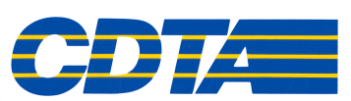

Memorandum

Date: May 15, 2017

To: Michael Collins

From: Rick Vines

Subject: Workplace Injuries – FY2017 Year End Report

I am providing a summary of our annual Workplace Injury Report to be presented at the Performance Oversight Committee this month. We have completed the ninth full year of our comprehensive program to improve workplace safety. The results from FY2017 as of
March 31, 2017 are as follows:

FREQUENCY SEVERITY

Period # Total Workplace Injuries # Lost Time Claims
Fiscal Year 2017

April 1, 2016 to March 31, 2017 77 19

COMPARISON:

Based on claim averages before the introduction of our Workplace Safety Program, our claims frequency is 49% less than historical averages and our severe claims are 55% less. Clearly the implementation of this program has created a safer work environment for CDTA employees.

Background

For fiscal years 2003 through 2008 we averaged 148 reported injuries per year, including 44 severe cases. We started our Workplace Safety Comprehensive Program in January of 2008 and for fiscal years 2009 through 2017 we averaged 76 reported injuries per year, including 20 severe cases. This shows a significant decrease in both reported injuries and severe injury cases since program inception, which has been sustained over time.

The following illustration (Employee Injuries- Figure 1.) represents a comparison of these two (2) periods; FY2003-FY2008 and FY2009-FY2017. It also shows FY2017 by itself. Injury frequency represents the number of injuries reported during the period. Severity represents the number of injuries which resulted in significant lost time from work.

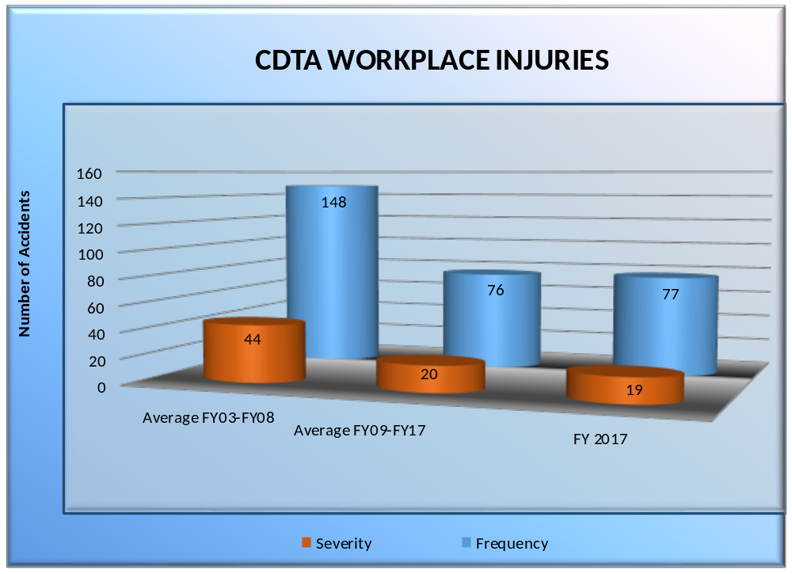

Figure 1.
Employee Injuries – FY 2003-2017
On Average, injuries have decreased by 49% and severe cases by 55%

Workers’ Compensation (WC) Cumulative Claim Costs

The following illustration (WC Cumulative Claim Costs-Figure 2.) represents a comparison of WC Claim Costs for Fiscal Years 2003-2017. This illustration demonstrates the positive financial impact of the program. For fiscal years 2003-2008 (Six Years) we spent $10,601,217 and for fiscal years 2009-2017 (Nine Years) we spent $9,090,130. This represents a spending decrease of 14%, or $1.5 million that includes three additional years. This has been achieved despite the cost of indemnity payments in New York State increasing over 100% since program inception of $400 a week to $900 per week. Unfortunately, mandated worker’s compensation costs continue to increase overall.

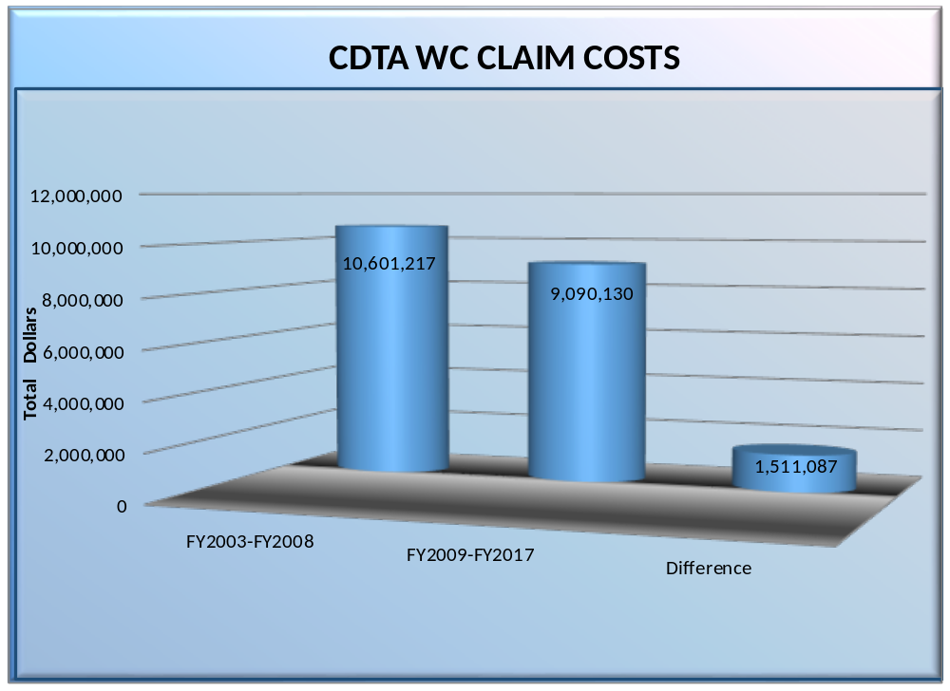

Figure 2.
WC Cumulative Claim Costs FY 2003-2017
Cumulative costs down 14%

Memorandum

Date: May 15, 2017

To: Chairman, Performance Oversight Committee

From: General Counsel

cc: Chairman, Board of Directors
Vice President of Finance and Administration
Chief Executive Officer

Subject: Risk Management and Workers Compensation Self-Insurance Accounts, as of 3/31/17

Our procedures require a quarterly review of the adequacy of the Risk Management Self-Insurance Account and the separate Workers Compensation Self-Insurance Account.
1. Risk Management:

CDTA is self-insured for most liability exposures up to $2 million. If at all possible, liability and automobile (AL and PD) claims are managed and defended internally. These claims include bodily injury, property damage, and certain other claims including no-fault.

Reasonable prudence dictates that in view of the $2 million self-insured retention and the volatility of the market, we should be prepared to absorb at least one total loss (preferably two) along with the projected value of incurred losses.

- Projected Losses (incurred but unpaid): $688,736
(increase of $222,000 (+47.6%) for the quarter)
- Self-Insured Retention (one) $2,000,000
- Market Value of Account: $3,944,509
(increase of $6,680 (+.17%) for the quarter)
We are currently able to cover one total loss plus the projected value of our incurred losses.
2. Workers Compensation:

We have retained an actuary to project monthly expenditures under the self-insurance program for workers’ compensation that was initiated on 8/14/02. This formula is based upon actual experience, an annual valuation at the end of the fiscal year, and an annual projection of expenses adjusted for actual expenses in the current year. The projection includes both IBNR and the projected value of claims, expenses and assessment.
- Projected Claims: $7,536,333
(decrease of $74,904 (-.98%) for the quarter)
• Market Value of Account: $8,004,739
(decrease of $25,119 (-.31%) for the quarter)

The ratio of predicted liabilities to account value continues to be approximately 1:1. We continue to be fully-funded in this program.

- Liability/Auto Claims:

As of 3/31/17, we had 31 pending liability claims, 21 of which were in suit. A number of inactive cases have been closed out. The majority of the active claims are in various stages of discovery, while a few have been referred to outside counsel and are scheduled for trial in the near future. As of 3/31/17, CDTA had ten liability claims with reserves of $10,000 or more, including seven liability claims with reserves of $25,000 or more. It is always our intention to carry adequate funds to cover the aggregate value of anticipated losses.

Conclusion: It is my opinion that the balances of the Risk Management and Workers’ Compensation Self-Insurance Accounts are adequate to meet the anticipated needs of CDTA and its subsidiaries at the present time. Due to the high-risk nature of our operations and our increasing ridership, we anticipate an increase in claims made against the Authority. Because of our self-insured status, it is prudent to maintain adequate funds to account for the increases in claims.

Please feel free to contact me if you have any questions.

AAA

