``

CDTA BOARD OF DIRECTORS

MEETING AGENDA

Wednesday, March 30, 2016

CDTA Board Room - 110 Watervliet Avenue

Start Time – 12:00 Noon; Anticipated End Time – 1:30 pm

Board Item Responsibility Page
Call to Order Dave Stackrow

Ascertain Quorum Dave Stackrow

Approve Agenda Dave Stackrow

Approve Minutes of February 24, 2016 Dave Stackrow 2

Recognition
- American Cancer Society Award Presentation Dave Stackrow
- William Plunkett, Jr. – 35 Years of Service

Committee Reports: (Action Items Listed)

Performance Oversight Committee (Met on 03/23/16) Tom Owens
- Contract Award for Parking System Upgrade 13
Audit Committee (Met on 03/23/16) Tom Owens

Governance Committee (Met on 03/24/16)
- Reviewing and Reaffirming Mission Statement 17

Planning and Stakeholder Relations Committee (Met on 03/24/16) Norm Miller
- FY2017 Budget Approval 19

Chief Executive Officer’s Report Carm Basile 24

Good of the Order (Added by Approval of the Chair)

Executive Session

Announcements

Upcoming Meetings (110 Watervliet Avenue)
April 27, 2016
May 25, 2016
June 29, 2016

Adjourn



CAPITAL DISTRICT TRANSPORTATION AUTHORITY
CAPITAL DISTRICT TRANSIT SYSTEM

CAPITAL DISTRICT TRANSPORTATION DISTRICT, INCORPORATED
CAPITAL DISTRICT TRANSIT SYSTEM, NUMBER ONE

CAPITAL DISTRICT TRANSPORTATION DISTRICT, INCORPORATED
CAPITAL DISTRICT TRANSIT SYSTEM, NUMBER TWO

CAPITAL DISTRICT TRANSPORTATION DISTRICT, INCORPORATED
ACCESS TRANSIT SERVICES, INC.

CDTA FACILITIES, INC.

MINUTES OF FEBRUARY 24, 2016 BOARD MEETING

MEMBERS PRESENT David M. Stackrow, Chairman
Georgeanna N. Lussier, Vice Chairwoman
Arthur F. Young, Jr., Treasurer
Joseph M. Spairana, Jr., Secretary
Corey L. Bixby
Denise A. Figueroa
Norman L. Miller
Thomas M. Owens

MEMBERS EXCUSED None

OTHERS PRESENT Carmino N. Basile, Chief Executive Officer
Amanda A. Avery, General Counsel
Christopher Desany, Vice President of Planning and Infrastructure
Michael P. Collins, Vice President of Finance and Administration
Philip C. Parella, Jr., Director of Finance
Frederick C. Gilliam, Director of Transportation
Jonathan E. Scherzer, Director of Marketing
Mark J. Wos, Director of Facilities
Richard J. Vines, Director of Risk Management
Lance C. Zarcone, Director of Maintenance
Thomas M. Marois, Manager of Graphics Services
Jaime Watson, Communications Manager
Sarah Matrose, Internal Auditor
Richard J. Fantozzi, Jr., Software Architect
Bessie E. Thompson, Descendants of Kings and Queens of Asia
Joyce Love, Descendants of Kings and Queens of Asia
Gwendolyn Hayles, the Low Foundation
Edward Rich, CDCAT
Kathy Colbert, Executive Assistant

CALL TO ORDER At 12:10 p.m., Chairman Stackrow called the meeting to order.

- Chairman Stackrow noted that a quorum was present.
AGENDA APPROVAL

Motion – Mr. Young
Seconded – Ms. Lussier
Carried Unanimously

APPROVAL OF JANUARY 27, 2016 BOARD MEETING MINUTES

Motion – Mr. Young
Seconded – Mr. Miller
Carried Unanimously

COMMITTEE REPORTS

PERFORMANCE OVERSIGHT COMMITTEE
Thomas M. Owens, Chair

- The Performance Oversight Committee met on Wednesday, February 17, 2016 at 12:00 noon at 110 Watervliet Avenue. Mr. Spairana chaired the meeting for Mr. Owens.

Consent Agenda Items

- Federal funds are provided to the State for the purpose of carrying out U.S. Department of Health and Human Services projects, which include providing transportation services to eligible participants. This item would permit the Authority to execute an agreement with the New York State Department of Transportation (NYSDOT) so that Albany County can continue to distribute free transit passes to Temporary Assistance for Needy Families (TANF) eligible clients.

- The Committee recommends authorizing an agreement with NYSDOT for an amount of $149,371, available on a reimbursement basis. This includes reimbursement for Authority administrative expenses (NTE 10%).

RESOLUTION NO. 09 – 2016
Executing an Agreement with NYSDOT for the Funding of Transit Passes for TANF-Eligible Clients in
Albany County

Motion – Mr. Young
Seconded – Ms. Figueroa
Carried Unanimously

Audit Committee Items

- The Internal Auditor provided the Committee with her monthly activity report. Work in progress included review of the Rensselaer Rail Station parking contract, risk assessment process, and HR benefits audit. Work completed included a review of the treasury process and preliminary PCI compliance research.

Investment Committee Items

- The Committee met, and there were no substantive issues.

- The monthly investment report provided by Hugh Johnson Advisors was received and reviewed by the Committee.

Administrative Discussion Items

- The Committee reviewed the quarterly report of the risk management and workers’ compensation self-insurance accounts and found them to be adequate at this time.

- The Monthly Management Report was in the members’ packets. Mortgage tax receipts exceeded budget projections in January by 9.5%. Wages were slightly under budget, and professional services exceeded budget this month. Liability claims were over budget this month, primarily due to one large settlement. Utilities were slightly over budget, but because of the warm winter weather, this category is well under budget for the year. The Authority is in a satisfactory cash flow position at this time and expects to see a small surplus at the end of the year.

- The Committee reviewed the Monthly Non-Financial Report. Overall, measurements this month were positive. Total ridership was up 4% for the month. There were 5 Preventative Maintenance Inspections not on time, and missed trips were at 27 this month. Means Distance between Service Interruptions was at 29,957. There were 13 preventable and 28 non-preventable accidents, and 88% of customer complaints were closed within 10 days.

- The Committee reviewed the annual litigation report in executive session. They also received an update on security initiatives. There was no action taken during the executive session.

- The next meeting of the Committee is scheduled for Wednesday, March 23, 2016 at 11:30 am at 110 Watervliet Avenue.

GOVERNANCE COMMITTEE
Report from David M. Stackrow, Chair

- The Governance Committee met on Thursday, February 18, 2016 at 11:30 am at 110 Watervliet Avenue.

Administrative Discussion Items

- Lisa Marrello provided an update on lobbying activities. She advised that she, Mr. Stackrow and Mr. Basile met with leadership members for most of the day on January 26. They talked about parity between upstate and downstate funding. Mr. Stackrow advised that they spent a good portion of their time requesting funding for a long-term, five-year capital appropriation that the Authority could use for planning capital projects.

- Ms. Marrello advised that Assemblywoman Patricia Fahy has sent a letter to Speaker Hastie requesting a five-year capital appropriation for upstate transit. More than 30 assembly members have signed the letter. Mr. Stackrow expressed his thanks to Assemblywoman Fahy for her support and the letter.

- Ms. Marrello also advised that the Assembly and Senate are gearing up for budget negotiations, and now would be a good time for Board members to meet with legislators to educate them on the needs of the Authority. She will invite the legislators to visit the Authority so they can get a better idea of the organization. Mr. Stackrow advised that an invitation has already been extended to the Governor’s Transportation Secretary, who seemed very interested in visiting the organization.

- The next meeting of the Committee is scheduled for Thursday, March 24, 2016 at 11:30 am at 110 Watervliet Avenue.

PLANNING AND STAKEHOLDER RELATIONS COMMITTEE
Report from Norman L. Miller, Chair

- The Planning and Stakeholder Relations Committee met on Thursday, February 18, 2016 at
12:30 pm at the 110 Watervliet Avenue office.

- Staff provided an update on the FY2017 operating budget and included recommendations for a pathway to a balanced budget. The budget provides a 3% wage increase that includes additional headcounts to improve efficiency for operations. As a result of the new labor agreement, the health care plan has been modified to contain costs. A small increase in non-personnel expenses has been included in the budget after several years of reducing and maintaining costs in these categories. Overall, the expense increase has been contained to 1.6%.

- Based on the Governor’s Executive Budget Proposal, the Authority is budgeting a 2.65% increase in state operating assistance and $3.6 million in capital funding. The Authority also received an unexpected increase in federal maintenance. Over the next few weeks, staff will fine tune budget categories and provide a final proposal in March.

- Jonathan Scherzer provided an update on the redesigned website. There have been increases in all categories, including page views and continued growth in real time sessions. The amount of time people spend on the website has increased by almost a minute, and the amount of pages read per visit has also increased. The site is now mobile-based as the majority of people who use the site do so from a mobile device. The site is constantly evolving with the integration of Navigator. A full online application for STAR customer registration is expected in the next few months.

- The next meeting of the Committee is scheduled for noon on Thursday, March 24, 2016 at
110 Watervliet Avenue.

CHIEF EXECUTIVE OFFICER’S REPORT

- The Chief Executive Officer provided a report of his activities for February 2016 and a summary of Key Performance Indicators for January 2016. A copy of the report is attached to these minutes.

- Mr. Basile advised that he met with the group that is advocating for improved taxi service, and they discussed things that can be done to facilitate this. The group includes elected officials, law enforcement personnel, tourism executives and community leaders. He said it is likely that the Authority will play a lead role in this. It is consistent with its work to provide people with a broader menu of mobility choices.

- Ms. Figueroa cautioned that the Authority should make sure that any taxi or alternate taxi services are meeting ADA requirements, noting that there have been problems with Uber services around the country.

- Mr. Basile advised that the Authority would not have oversight over Uber; only the taxi service that it has now. He also advised that the Mr. Gilliam, the Transportation Director, is spending about 50% of his time working on improvements in the STAR Department, making sure it is right sized and working as efficiently as it can be. He said that an update on STAR will probably be provided at the next Performance Oversight and Stakeholder Relations Committee meeting.

FOR THE GOOD OF THE ORDER
- None

EXECUTIVE SESSION
- None

ANNOUNCEMENTS
- None

UPCOMING MEETINGS

- Subject to the call of the Chair, Mr. Stackrow announced the following meeting dates:

March 30, 2016
April 27, 2016
May 25, 2016

ADJOURNMENT – 12:50 PM
Motion – Mr. Owens
Seconded – Mr. Spairana
Carried Unanimously

Respectfully submitted,

_______________________________________
Joseph M. Spairana, Jr., Secretary

Dated: February 24, 2016

CHIEF EXECUTIVE OFFICER’S REPORT

I am providing a report of my activities for February 2016 and a summary of the organization’s Key Performance Indicators for January 2016.

Our work to develop and improve the system continues. Advocacy efforts are in full swing, and the past month included several events to highlight the need for a more thoughtful investment in infrastructure across upstate New York. We are telling the CDTA story of success and talking about the work we have done to make our system and facilities attractive to the people of the Capital Region. We work as a team with other transit systems, lobbyists and stakeholders to put forth a consistent and positive message about the need for better mobility for upstate residents. We are thankful that the Governor has recognized the importance of transit in his Executive Budget Request, and we are outlining why more resources need to be included in the final state budget. Our message is being heard, and this work will continue in the coming weeks.

Ridership on our system continues to be at very high levels. In fact, we are on pace to finish the year at/near 17 million boardings. With a little luck and some good weather, we could break our annual ridership record again. Total boarding count for January was up nearly 4% from last January. Year to date, there have been 14.2 million boardings on our buses. Ridership increases are across our network of services, with trunk routes showing the most sustained increases. Ridership on NX buses is down about 3%, which is not surprising as that service is sensitive to economic factors, notably the price of fuel.

Development of our annual operating and capital plan continues. This work stretches across all CDTA departments, and it is truly a team effort. Our staff has focused on expense lines, modified them and reduced spending over the past few years. In developing the budget, we make decisions to spend money wisely and encourage staff to work in areas where there is the most possibility for success. These efforts show themselves in year-end reports where we see expense lines below expectations and new revenue opportunities being developed. Our finance staff coordinates budget development, and we are working closely with the Planning and Stakeholder Relations Committee regarding the options available to us. The fact that we have options available puts us far ahead of other systems, and that is part of our advocacy message at the Capitol.

The work we are doing and the success we have achieved was on display at our second annual state of CDTA breakfast on February 3 at the Hilton Garden Inn in Troy. Dave Stackrow kicked the morning off with comments about vision and commitment, and our woman on the street interviews were well done and well received. I am proud of the work we do and the things that we have accomplished. It is great to share our ambitious agenda with friends and supporters. This is part of our consistent message of communication – we want people to know what we are doing, why we are doing it, and why it should matter to them. In that regard, the morning was very successful, and we are already thinking about next year’s event. Thanks to Board members and staff who attended.

Saratoga route restructuring is moving towards implementation. In the coming weeks, we will install new bus stops and shelters. Once that is complete, education and promotion will begin to insure that customers are aware of the changes and know how they will impact them. We will circle back with community leaders to remind them of our plans, and how the changes might impact their constituents. At this point, we are confident that the new service deployment puts buses where people want and need them most. It also balances the desires of different groups (seniors, college students, visitors). It will provide more service and better connections to places that people want to travel to in Saratoga. The new service will begin in spring 2016; the exact date to be determined.

Planning work continues on the Uncle Sam Transit Center in Troy and on the intersection and BRT station at Lark and Washington in Albany. Staff is working on lease arrangements at the Uncle Sam site, and work has begun on the design of the center. This includes the scheduling of buses to accommodate a new operations hub at the Transit Center. We are hopeful of a late 2016 ground breaking. We have modified our plans at Lark and Washington to accommodate community input. The design of the intersection improvements continues, and we are developing construction documents to begin the contractor selection process. We are hopeful of an early fall groundbreaking on this important safety and transit operations project.

Work on Navigator continues to move along. We are adding to the pilot group of customers who are using cards on buses. This provides our staff with experiential information and allows them to watch the system accumulate data and information. Back room features are also being tested, including automatic loading of funds from credit cards and automated reload of products to customer accounts. At the same time, training has begun for call center agents, sales and fulfillment staff, and people in finance to make sure they are ready to support the system and present Navigator to customers in the best way possible. Lots of moving parts and lots still left to do, but everything is moving in the right direction, and there is a growing sense of excitement as we move closer to full scale rollout.

One of our priorities is to expand the menu of travel options that we provide to customers. In that regard, we continue to examine ways to be more active in this area. As we have discussed, I am meeting with a group of elected officials and tourism representatives to work towards oversight responsibility for taxi services. This may be an opportunity for CDTA, and we are working with state leaders to insure that we can do this work within our legislative purpose. The concept of CDTA being the leader in this has been well received. Better oversight and more customer support services will improve the reliability and the image of taxi services in our region. At the same time, we are also looking to manage a regional bike share program. This has been tested by CDTC, and it generated a good deal of excitement in the region. We see this as a tie-in to our bike rack program (on buses) and view Navigator as the perfect payment access program. Lastly, we are looking at the car share program, which operates in downtown Albany, to see how it can fit into our menu of choices. All of this work positions CDTA as a community resource, a problem solver, and a crucial piece of the regional economic development process.

Several of us will travel to Washington in a few weeks to attend the annual APTA Legislative Conference. This is one of the most important APTA events of the year, and it is good to hear the latest news from Washington regarding infrastructure policy and funding. We will schedule meetings with our legislative delegation so that we can outline the work that CDTA is doing. Please let Kathy know if you want to be registered.

A quick update on staffing. Patricia Cooper has joined us as Comptroller in the Finance Department; Stephanie Plant is our new Human Resource/Training Manager; and, Chip Annello is aboard as our Manager in the Facilities department. At the same time, we have completed the backfill caused by retirements and promotions in the payroll and administrative functions in the operations department. Lots of movement, with new people and new ideas joining the CDTA family. All of this is positive, and I like the energy and enthusiasm that it brings. Very nice work by our human resource staff to manage the traffic in and out of the building(s).

Last but not least, construction activity continues at 110 Watervliet Avenue. Work on locker rooms, showers and bathroom facilities is moving along. It has been at least 50 years since any work of significance has occurred in this part of the building. It will be a great upgrade for our employees, and we are looking at a mid-April completion. As you can see, the board room makeover is complete, and it turned out nicely. There are a few finishing touches left to be done, but the room is more comfortable and conducive to the work we do. We hope you are pleased with the final outcome.

Key Performance Measures
Key performance measures for the organization are included in our monthly reports. Data is for January, and it is compared to January 2015.

System ridership totaled 1.278 million boardings, up close to 4% from January 2015 (1.224 million). Year-to-date, ridership is up about 1% from the same period last year, with 14.2 million boardings on our buses. We expect to be at or near 17 million boardings for the year and could break last year’s ridership record (amazing, given the dramatic drop in fuel prices).

As discussed in board committee meetings, our financial situation is very solid, and our position offers flexibility/choices as we move into the new fiscal year. Revenue for the month was 2.6% under budget; however, expenses were 1% lower than expected, putting us spot-on for the month. Year-to-date figures provide a clearer picture of our financial situation. Total revenue is almost exactly where we expected it to be. Moving forward, we will adjust expectations from the customer revenue line so we aren’t consistently behind budget (a correction that is 3 years overdue); on the expense side, we are about 2% ahead of projections. A review of management reports shows most expense lines are lower than expected, reflecting the work of our employees to manage their responsibility areas. At this pace, we will finish the year about $750,000 better than expected. We are talking about how to show this and use surpluses moving forward.

As reported in non-financial reports, we missed 27 trips on the fixed route system; last January, we missed 14 trips. We continue to manage head counts, bring in new employees and monitor on the job/off the job lists. All of this work is designed to align organizational resources to service needs. Although this is challenging, I see progress and reason for optimism. A continued salute to our supervisors, dispatchers, bus operators and maintenance personnel who do an outstanding job providing customers with reliable service every day.

There were no trip denials in STAR. We reported 41 accidents in January, with 13 categorized as preventable. Last January, we reported 39 accidents with 7 preventable. 96% of our maintenance inspections were done on time; last January, we were at 99%. Our call center processed 303 comments in January as compared to 273 last January. Response time to close complaint investigations was at 88%; last January, we closed 90% of the comments in the 10 day window.

Activity Report
The following is a summary of my activities for the month. We continue to meet with elected officials, community leaders and stakeholders to tell the CDTA story. Our advocacy work continues with full deployment of resources. Our lobbying firm, Wilson Elser is fully engaged, and we are using a team approach with NYPTA and its members to advocate for the needs of transit systems across the state.

- On January 28, I recorded a podcast with Doug Eadie and Steve Bland. The subject was Getting Ready to Work with a Board. Doug and Steve are experts in this area, and I provided my perspective, mostly regarding the CDTA governance model. You can find the podcast at dougeadie.com.

- On January 29, I met with Assemblyman John McDonald and Albany County Convention and Visitors Bureau CEO Michele Vennard to talk about our work to improve taxi service and specifically the role that CDTA can play in this work.

- On January 30, my wife Sheila and I attended our annual Employee Awards dinner at the Marriott on Wolf Road. Over 150 employees attended (300 with guests), and it was great to honor our best workers as measured by outstanding performance in attendance, safety and customer service. Many of our management staff also attended. Thanks to Art and Anne Young and Marilyn and Norm Miller who represented the Board. A great job by our staff planning committee – we all had a great time.

- On February 1, Jon Scherzer and I met with representatives from Rush Gaming to talk about transit services and a Universal Access arrangement for the new casino in Schenectady. We have been talking with Rush for some time, and we anticipate a new partnership with them concurrent with the opening of the casino in 2017.

- On February 1, I chaired a meeting of the NYPTA board of directors at the Hampton in downtown Albany. In addition to association business matters, a good deal of the meeting was spent discussing our Transit Advocacy activities (the following day).

- On February 2, I met with a number of state elected officials as part of the NYPTA delegation. This included meetings with Speaker Carl Heastie, Assembly transportation committee chair David Gantt, and staff from Assembly Ways and Means.

- On February 2, I chaired a panel discussion on transit services and the perspectives from community leaders and elected officials. The advocacy centerpiece was attended by nearly 100 people, including elected officials and their staff.

- On February 3, we held our second annual State of CDTA breakfast at the Troy Hilton Garden Inn. Dave Stackrow welcomed everyone and provided an overview. Close to 150 of our partners and community leaders attended, and we provided them with an update on our accomplishments and plans for the coming year. We integrated our guests into the presentation, which was themed around community outreach. Thanks to Board members who attended and thanks to Jon Scherzer and Jaime Watson for working out all of the event details.

- On February 9, Lisa Marrello and I met with Robert Mujica and his staff. Mr. Mujica is the new Director of the Budget after spending many years at Senate Finance. We had a good discussion about CDTA’s success and the things we are doing to improve our system and attract customers.

- On February 9, I was interviewed by reporters from Politico and the Times Union. In both interviews, I spoke of the need for more investment in upstate infrastructure, the lack of equity between upstate and downstate funding, and the success of CDTA in attracting ridership.

- On February 10, I met with Rensselaer City Planner Charles Moore to discuss some of their grant activities and ways that we can support each other to make the area around the rail station more economically robust.

- On February 10, Jon Scherzer and I met with Sam Iuvino and his staff from Lamar Transit Advertising. We get together periodically to talk about our relationship and ways to make it better. As you will recall, we are coming off two superlative revenue years, and we are looking forward to more sales, more revenue and more opportunities.

- On February 16, I met with Bob Brown from Upstate/Brown Transit Company. The Brown’s operate our Northway Express service, and we meet periodically to insure that our communication lines are open and fully functional.

- On February 17, I attended a meeting of the board of directors for the United Way of the Greater Capital Region. I am a member of the Board and enjoy working with them to provide programs that feed and educate those in need, especially children. As we have discussed, CDTA employees are generous givers to the United Way, and our campaign is one of the strongest in the region.

- On February 17, I met with John Evers from the Business Council of New York State to talk about their advocacy and lobbying work and ways that they might be able to help us position CDTA and transit at the State Capitol.

- On February 19, we held a staff meeting for all Authority staff. We do this about once every 6-8 weeks to make sure that everyone is up to speed on the things we are working on and developments of interest to the staff. More than 60 people attended, which was great to see (I think they wanted to get a closer look at the renovated board room).

- On February 22, Chris Desany and I met with Guilderland Town Supervisor Peter Barber. Peter recently began his term as Supervisor, and we wanted to bring him up to speed on our activities in the town, most notably our work at Crossgates Mall and plans for a new BRT line and a Transit Center.

- On February 22, I attended a Labor Management Committee meeting (CDTA and ATU). The purpose of the LMC is to talk about issues at a high level and to develop strategies regarding our relationship and the direction we want to go. Corey Bixby was instrumental in insuring that we resumed LMC meetings and that we use them as a mechanism to advance our agenda to support and develop CDTA employees.

- On February 23, I provided a presentation to the Capital Region Chamber of Commerce. I was invited by Mark Eagan to speak to their board members about CDTA, our work in the community and why we matter to the business community. There are 45 members of the Chamber board and about 75% of them were in attendance. Thanks to Jaime Watson for helping me develop the presentation and attending the meeting.

- Earlier this morning, I met with the group that is advocating for improved taxi service and discussing things that can be done to facilitate this. The group includes elected officials, law enforcement personnel, tourism executives, and community leaders. It is likely that CDTA will play a lead role in this; it is consistent with our work to provide people with a broader menu of mobility choices. Details to follow.

CAPITAL DISTRICT TRANSPORTATION AUTHORITY
RESOLUTION NO. 10 - 2016

Awarding Sole Source Contract to Access Technology Integration, Inc.

WHEREAS, the Capital District Transportation Authority (the “Authority”) is charged by title 11-C of the Public Authorities Law with providing omnibus transportation within the Capital District transportation district, and
WHEREAS, the Authority is authorized by Public Authorities Law section 1307(5) to improve its facilities, and
WHEREAS, in 2001, the parking system at the Rensselaer Rail Station was competitively procured from Access Technology Integration, Inc. (“ATI”), and
WHEREAS, the fee computers and parking software associated with the Rensselaer Rail Station parking system are currently unsupported, requiring updating to current versions, and
WHEREAS, ATI is able to provide the required upgrades to the parking system without costly interfaces or customization, and
WHEREAS, ATI has provided competitive pricing and high quality service in the past, and the price proposed for parking system upgrades has been deemed fair and reasonable, and
WHEREAS, the Authority now recommends the sole-source award of a parking system upgrade contract to ATI, for a total amount not to exceed $58,900.

NOW, THEREFORE, IT IS RESOLVED AS FOLLOWS:
- The Authority hereby awards a sole source contract for parking system upgrades to ATI for a total amount not to exceed $58,900, subject to acceptance and satisfaction of all contract terms and requirements.
- Authority Staff is hereby authorized to execute the necessary documents.
- The source of funds will be the FY2016 Capital Program.
- This Resolution shall take effect immediately.

CERTIFICATION

The undersigned, duly qualified and acting as Secretary of the Capital District Transportation Authority, certifies that the foregoing is a true and correct copy of a resolution adopted at a legally convened meeting of the Capital District Transportation Authority held on the 30th day of March, 2016.

Dated: March 30, 2016 __________________________________
Joseph M. Spairana, Jr., Acting Secretary

Capital District Transportation Authority
Agenda Action Proposal

Subject: Sole source contract award to Access Technology Integration, Inc.

Committee: Performance Oversight.
Committee Meeting Date: March 23, 2016
Board Action Date: March 30, 2016

Background:
The fee computers and the parking software at the Rensselaer Rail Station are unsupported and require updating to current versions.

Purpose:
Updating these systems will not only ensure PCI compliance but move the parking software system from the Rail Station to 110 Watervliet Ave, making it manageable from a centralized location.

Summary of Proposal:
The OPUS parking system was competitively procured in 2001 from Access Technology Integration (ATI). ATI is still the vendor who maintains and services the parking system. ATI is able to provide the required upgrades to the system they already maintain without interfaces and customization. Staff recommends a sole source contract for upgrades to the Rensselaer Rail Station parking system be awarded to ATI of Wynantskill, New York for an amount not to exceed $58,900. Staff has compared this pricing with prices paid for the same or similar services from other ATI customers and found it to be fair and reasonable. ATI is a certified Women’s Business Enterprise (WBE) in New York State.

Financial Summary and Source of Funds:
Not to exceed $58,900. It is funded through the FY2016 Capital Program.

Prepared by:
Stacy Sansky, Director of Procurement

Project Manager:
Christopher Desany, Vice President of Planning & Infrastructure

Date: March 04, 2016
To: Stacy Sansky, Director of Procurement
From: Christopher Desany, Vice President of Planning and Infrastructure
Re: Sole Source Recommendation for Rensselaer Rail Station Fee Computer Upgrade

Background:
In 2001, CDTA implemented the OPUS parking system to control and collect fees for the Rensselaer Rail Station parking garage and surface lots. This system was competitively procured and installed by Access Technology Integration, Inc. (ATI) who still supports the current setup. The fee computers are using an unsupported (Microsoft) operating system, and the iParcProfessional parking software is 3 revisions behind the current release.

The unsupported operating system will be updated to ensure PCI compliance. The iParcProfessional Software will be upgraded and moved from the Rail Station to 110 Watervliet Ave. This work will allow CDTA access to the latest features, provide the ability to manage the system from a centralized location, and will be a first step in a move toward a cloud based parking system.

Justification:
This recommendation is to award a sole source contract to Access Technology Integration, Inc. for upgrading the fee computers and software. This system was originally installed and is maintained by ATI. Additional reasons to support this sole source recommendation include:

- Access Technology Integration, Inc. is familiar with the many nuances of the system and its relationship to our requirements and therefore has full knowledge of CDTA needs.
- Utilizing this vendor will result in a zero net increase in vendors at CDTA.
- Utilizing this vendor will require no third-party integration or customization, which reduces the risk inherent in custom third-party vendor development.
- This work is of a security and time sensitive nature. Without doing this upgrade, CDTA risks not being PCI compliant with the parking system.
- We have documentation on file noting the cost paid by established customers for ATI’s installation and migration services, which confirms fair and reasonable pricing for this contract.

Recommendation
I am recommending that a contract be awarded to Access Technology Integration, Inc. for replacement and upgrade services in an amount not to exceed $58,900.

CAPITAL DISTRICT TRANSPORTATION AUTHORITY
Staff Contract Award Certification
1. TYPE OF CONTRACT (check one):
__ _ Construction & Maintenance _ X___ Goods, Commodities & Supplies ____ Bus Purchase
____ Services & Consultants __ __ Transportation & Operational Services

2. TERMS OF PERFORMANCE (check one):
_ X_ One-Shot Deal: Complete scope and fixed value
____ Fixed Fee For Services: Time and materials - open value
__ _ Exclusive Purchase Contract: Fixed cost for defined commodity with indefinite quantity
____ Open Purchase Contract: Commitment on specifications and price but no obligation to buy
____ Change Order: Add on to existing contract

3. CONTRACT VALUE:
__$58,900 (NTE)________________________ fixed estimated (circle one)

4. PROCUREMENT METHOD (check one):
_ ___ Request for Proposals (RFP) __ __ Invitation for Bids (IFB) __X__ Other

5. TYPE OF PROCEDURE USED (check one):
____ Micro Purchases (Purchases up to $2,499.00) ____ Small Purchases ($25,000 up to $$100,000)
__ _ Sealed Bid/Invitation for Bids (IFB) (Over $100,000) __ __ Request for Proposals (RFP)
____ Professional Services (Over $25,000) __X_ Sole or Single Source (Non-Competitive)

6. SELECTION CRITERION USED:
Number of Proposals/Bids Solicited #__1___ or Advertised
Number of Proposals/Bids Received #__1_____

Attach Summary of Bids/Proposals

- Disadvantaged Business Enterprise (DBE) involvement
Are there known DBEs that provide this good or service? Yes No
Number of DBEs bidding/proposing ___1_______
DBE Certification on file? Yes No Not Applicable
Was contract awarded to a DBE? Yes No
Number of DBE Subcontractors _____0_____

8. LEGAL NAME and ADDRESS OF CONTRACTOR/VENDOR: Access Technology Integration, Inc.
PO Box 233
Wynantskill, NY 12198
9. SOURCE OF FUNDS: FY15 Capital Plan

10. COMPLIANCE WITH STATE AND FEDERAL RULES:
Non-Collusion Affidavit of Bidder (Yes, No, N/A)
Disclosure & Certificate of Prior Non-Responsibility Determinations (Yes, No, N/A)
Disclosure of Contacts (only RFPs) (Yes, No, N/A)
Certification with FTA’s Bus Testing Requirements (Yes, No,)

11. RESPONSIBLE STAFF CERTIFIES THE INTEGRITY OF THIS PROCUREMENT/CONTRACT:

Stacy Sansky, Director of Procurement DATED: March 15, 2016

CAPITAL DISTRICT TRANSPORTATION AUTHORITY
RESOLUTION NO. 11 - 2016

Reviewing and Reaffirming Mission Statement

WHEREAS, the Capital District Transportation Authority (“Authority”) is charged by title 11-C of the Public Authorities Law with providing omnibus transportation within the Capital District transportation district, and
WHEREAS, the Authority conducts its operations in accordance with the mission statement, “CDTA plans, finances, implements and delivers transit services that take people where they want to go in the Capital Region safely, efficiently and at a reasonable cost”, and
WHEREAS, pursuant to the Public Authorities Law, the Authority has undertaken a review of its mission statement, to ascertain whether the Authority’s current mission is accurately described, and
WHEREAS, after review and discussion, the Authority has determined that the mission statement accurately describes the Authority’s current mission and does not require revision at this time.

NOW, THEREFORE, IT IS RESOLVED AS FOLLOWS:

The Authority’s mission statement, “CDTA plans, finances, implements and delivers transit services that take people where they want to go in the Capital Region safely, efficiently and at a reasonable cost” is hereby reaffirmed.

CERTIFICATION

The undersigned, duly qualified and acting as Secretary of the Capital District Transportation Authority, certifies that the foregoing is a true and correct copy of a resolution adopted at a legally convened meeting of the Capital District Transportation Authority held on the 30th day of March, 2016.

Dated: March 30, 2016 __________________________________
Joseph M. Spairana, Jr.

CAPITAL DISTRICT TRANSPORTATION AUTHORITY
MISSION STATEMENT

CDTA plans, finances, implements and delivers transit services that take people where they want to go in the Capital Region safely, efficiently and at a reasonable cost.

CAPITAL DISTRICT TRANSPORTATION AUTHORITY
RESOLUTION NO. 12 - 2016

Approving the FY2017 Operating Budget and
the Proposed FY2017-FY2021 5-Year Capital Plan

WHEREAS, the Capital District Transportation Authority (the “Authority”) is required by Public Authorities law sections 1305-a and 1306 to prepare and file an annual budget; and
WHEREAS, the Authority has proposed a FY2017 Operating Budget for the Capital District Transportation Authority in the amount of $81,431,531, and a FY2017-FY2021 5-year Capital Plan in the amount of $240,818,988; and
WHEREAS, said proposed FY2017 Operating Budget and 5-Year Capital Plan have been presented and reviewed; and
WHEREAS, the adoption of the proposed FY2017 Operating Budget and 5-Year Capital Plan has been recommended by the CDTA Planning and Stakeholder Relations Committee;

NOW, THEREFORE, IT IS RESOLVED AS FOLLOWS:

- The Authority hereby approves and adopts an Operating Budget of $81,431,531 for fiscal year 2017, a copy of which is attached to and made part of this resolution.
- The Authority hereby approves and adopts a 5-Year Capital Plan in the amount of $240,818,988, a copy of which is attached to and made part of this resolution.
- This Resolution shall take effect immediately.

CERTIFICATION

The undersigned, duly qualified and acting as Secretary of the Capital District Transportation Authority, certifies that the foregoing is a true and correct copy of a resolution adopted at a legally convened meeting of the Capital District Transportation Authority held on the 30th day of March, 2016.

Dated: March 30, 2016 __________________________________
Joseph M. Spairana, Jr., Secretary



Memorandum

Date: March 18, 2016

To: Chairman, Planning and Stakeholder Relations Committee
Members, Planning and Stakeholder Relations Committee

From: Mike Collins, Vice President of Finance & Administration

Subject: FY2017 Operating and Capital Budget Recommendations

Summary

We are providing a balanced budget for FY2017 based on Committee guidance over the past several meetings. The budget is ready for final review and approval. Since our last meeting, we have lowered expenses from a 1.6% increase to a 1.3% increase, and have modified revenue projections without using reserve accounts to balance the budget.

Revenue

We have increased our federal maintenance line from $8.9 million to $10.6 million because New York State has provided additional capital money. The $10.6 million represents a draw of 70% of our 5307 federal allocation. State Operating Assistance will increase by at least $900,000, and we anticipate a $500,000 carryover from the prior fiscal year.

We are increasing our Mortgage Recording Tax (MRT) projection from $9.8 million to $10.5 million based on FY2016 budget projections and our review of past trends. We will not use reserve account funds for this operating budget (for FY2016, this was $2.4 million). This is the first time since FY2008 that we have not used reserve account funds to balance the budget.

There may be more good news coming out of state budget deliberations for operating assistance and capital funding. Should the state pass a budget with additional assistance for CDTA, we may want to make a budget adjustment as early as next month.

Expenses

We budgeted a 3% increase in wages that provides additional headcounts to improve efficiency and flexibility for service. This is much needed as we strive to meet additional demand.

As a result of our labor agreement, we modified our health care plans to slow the growth of expenses. We also changed the employee pension plan structure to eliminate lump sum payments and defer employer contribution increases. At the same time, the New York State Employees Retirement System has reduced rates resulting in decreased pension payments to the state. All of these actions will reduce the Other Benefits line (mostly pensions) by $600,000.

For the past few years, we have reduced or maintained non-personnel expenses, which accounts for 30% of our expenses. This year we proposed to increase these expenses and reinvest in the maintenance area. Fuel costs make up about 9% of our budget, and we expect to realize a $400,000 reduction in costs over last year.

The total operating budget is $81.4 million, a 1.3% increase from last year. The budget composite is attached.
Capital Plan

There is positive news coming from the New York State budget process. We are anticipating at least $3.6 million from the state for this year’s capital plan, about $1 million more than last year. This additional funding allows flexibility and the ability to order at least 12 fixed route buses and 6 STAR buses in FY2017.

The five year capital plan is attached and must be submitted to the state on an annual basis. The plan is funded in year one. Some highlights include the Uncle Sam Transit Center and Lark & Washington safety improvements that are both funded and anticipated to start in FY2017. The capital plan also includes a new radio system (funded) and our two BRT lines – The River Corridor and Washington/Western Avenue (both in the Federal Small Starts Program).

The FY2017 capital plan is funded at $22.2 million, and the five year proposed plan is projected to cost $240 million. Year one of the capital plan is funded through a combination of 5307 money and other federal/state grants.

Recommendation

We recommend approval of the FY2017 operating and capital plans by the Committee with an advancement and endorsement to the full board.

Copy: Chief Executive Officer
Senior Staff
Director of Finance

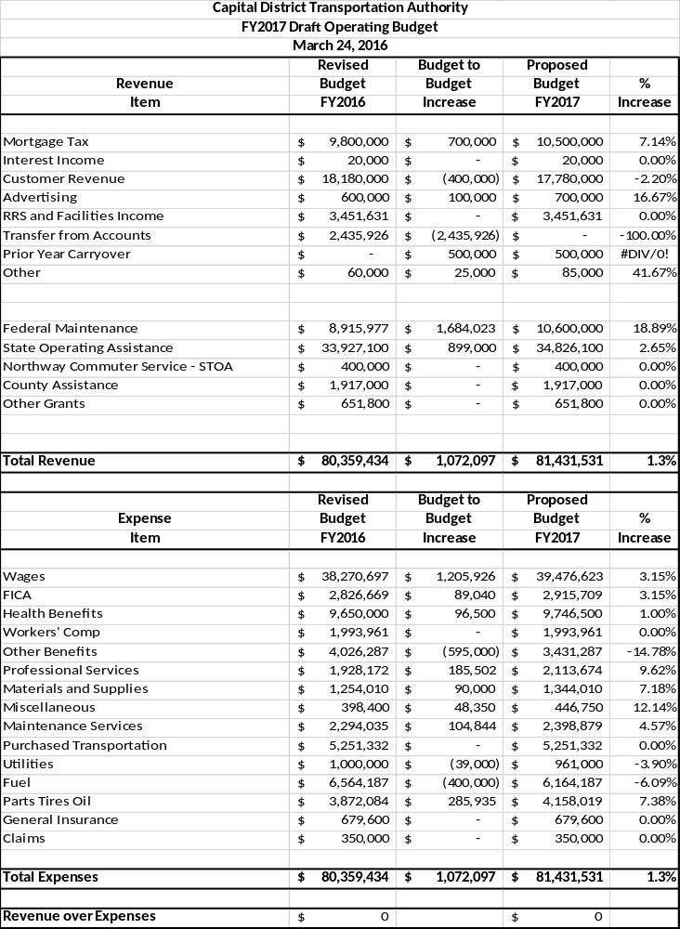
CDTA Five Year Capital Plan FY2017 - FY2021
Project Name | FY2017 | FY2018 | FY2019 | FY 2020 | FY 2021 | Total
Automated Fueling Meters (3 divisions) | $0 |  | $150,000 | $0 | $0 | $150,000
Uncle Sam Transit Center | $2,890,000 | $1,110,000 | $0 | $0 | $0 | $4,000,000
Lark and Washington Safety Improvements | $500,000 | $1,500,000 | $0 | $0 | $0 | $2,000,000
State and Broadway Improvements (Sch) | $20,000 | $0 | $0 | $0 | $0 | $20,000
River Corridor Stations, TSP (TAP) | $2,050,000 | $0 | $0 | $0 | $0 | $2,050,000
Downtown Albany Intermodal | $0 | $0 | $0 | $0 | $35,000,000 | $35,000,000
High Speed Roll-Up Door at Troy & Sch | $0 | $70,000 |  | $0 | $0 | $70,000
Maintenance Department Renovations | $0 | $0 | $0 | $550,000 | $0 | $550,000
Albany Bathroom & Locker Room Reno | $550,000 |  |  | $0 | $0 | $550,000
Maintenance Department Admin Offices | $0 | $125,000 | $0 | $0 | $0 | $125,000
Maintenance Training Room | $0 | $250,000 | $0 | $0 | $0 | $250,000
Paint Albany Maintenance Area | $0 | $15,000 | $0 | $0 | $0 | $15,000
Troy Maintenance Renovations | $0 | $200,000 | $0 | $0 | $0 | $200,000
Non-Revenue Vehicles | $0 | $80,000 | $100,000 | $0 | $150,000 | $330,000
Preliminary Engineering | $100,000 | $100,000 | $100,000 | $100,000 | $100,000 | $500,000
Routine Maintenance | $125,000 | $100,000 | $100,000 | $100,000 | $100,000 | $525,000
Troy Lift Replacement Project (4) | $0 | $0 | $640,000 | $0 | $0 | $640,000
Street Amenities (Shelter Program) | $235,000 | $350,000 | $150,000 | $350,000 | $150,000 | $1,235,000
CAD/AVL | $4,703,125 | $4,703,125 | $4,703,125 | $0 | $0 | $14,109,375
Hardware and Software Replacements | $409,613 | $100,000 | $100,000 | $100,000 | $100,000 | $809,613
Mobile Data Communications System | $0 | $95,000 | $75,000 | $50,000 | $75,000 | $295,000
BRT – River Corridor | $0 | $17,500,000 | $17,500,000 | $0 | $0 | $35,000,000
BRT - Washington - Western | $0 | $32,500,000 | $32,500,000 |  | $0 | $65,000,000
iRide Branding | $250,000 | $300,000 | $300,000 | $300,000 | $300,000 | $1,450,000
Security | $50,000 | $50,000 | $50,000 | $50,000 | $50,000 | $250,000
Travel Demand Management | $600,000 | $330,000 | $330,000 | $330,000 | $330,000 | $1,920,000
Innovation Platform | $100,000 | $0 | $0 | $0 | $0 | $100,000
Routine RRS Maintenance | $75,000 | $225,000 | $100,000 | $100,000 | $100,000 | $600,000
RRS - Top Deck Recoating | $1,000,000 | $0 | $0 |  | $0 | $1,000,000
Articulated Buses | $0 | $1,600,000 | $0 | $0 | $1,800,000 | $3,400,000
Bus Replacement Program | $6,000,000 | $10,500,000 | $11,000,000 | $11,500,000 | $12,000,000 | $51,000,000
Fleet Financing 2012 | $930,000 | $930,000 | $930,000 | $930,000 | $930,000 | $4,650,000
Fleet Financing 2014 | $780,000 | $780,000 | $780,000 | $780,000 | $780,000 | $3,900,000
STAR Buses | $510,000 |  | $300,000 | $0 | $300,000 | $1,110,000
Nx Coach Replacement | $0 | $1,875,000 | $1,200,000 | $1,200,000 | $1,200,000 | $5,475,000
Mid-Life Hybrid Replacement | $300,000 | $500,000 | $500,000 | $500,000 | $500,000 | $2,300,000
Floor Sweeper | $60,000 | $60,000 | $0 | $0 | $120,000 | $240,000
 | $22,237,738 | $75,948,125 | $71,608,125 | $16,940,000 | $54,085,000 | $240,818,988

Memorandum

March 30, 2016

To: Chairman of the Board
Board Members

From: Chief Executive Officer

Subject: Chief Executive Officer Report for March 2016

Overview
I am providing a report of my activities for March 2016 and a summary of the organization’s Key Performance Indicators for February 2016.

We are nearing the end of the fiscal year, and thanks to the work of our staff and the Planning and Stakeholder Relations committee, we have a balanced budget for 2016-2017. The spending plan grows by only 1.3%, which is outstanding given anticipated growth in wages and benefits. The budget is thoughtful and appropriate to the revenue and expenses that we anticipate. It reflects the work of the entire CDTA team with recommendations from all of our departments. We are very pleased that it does not require the use of reserve funds and allows us to fully appropriate our capital needs. This is the first time in several years that a transfer has not been used to balance the budget. It is great that we have options available as we develop our financial plan, something that hasn’t always been the case. Based on a review of our service levels and demand for them, we anticipate some additions to frequencies and span. Most of the enhancements will be on trunk routes, especially those that are on/near corridors scheduled for BRT upgrades.

Transit advocacy work continues at full speed. As discussed in Governance committee meetings, our partners at Wilson Elser are representing us at the Capitol, working with the Assembly, Senate and the Governor’s office to highlight the work that CDTA does in the Capital Region. This includes, discussion about operating needs, demand for services and capital requirements over the next few years. It is coordinated with our state association (NYPTA), and with transit systems across the state, particularly along the I-90 corridor. This collaborative approach to advocacy has been successful over the past few years, and we have developed an effective working model. Our team is on-point and convincing in their work with elected and appointed officials. We are thankful for the inclusion of more transit funding in the Governor’s executive budget request, and the support we receive from legislators to increase funding levels and the commitment term.

Several of us traveled to Washington D.C. earlier this month to attend the APTA legislative conference. In addition to hearing information about FAST, we spent a good deal of time talking with our peers in the transit industry about common issues and opportunities. We were fortunate to meet with Congressman Paul Tonko and Senator Chuck Schumer. In the meetings, we highlighted the work we do, the demand for our service and the need to expand the mobility options we offer. Both Congressman Tonko and Senator Schumer pledged to support our work and provide assistance with the federal agencies that we work with for funding opportunities.

Outreach and collaboration activities continued throughout the month to support our advocacy work. We are looking to expand the menu of travel options that we provide to customers. I am meeting with elected officials and tourism representatives to work towards oversight responsibility for taxi services. This has been well received, and we are evaluating how much of this work we can assume and what changes would need to be made to our administrative structure to accommodate this. The concept has been well received, and it has begun to attract media attention. Better oversight and customer support services will improve the image of the taxi industry. We are also advancing efforts to manage a regional bike share program. The task force that developed the concept is ready for it to be operational; we are well positioned to do this. It will be a great tie-in to our bike rack program, with Navigator being a perfect and timely access program. Lastly, we are looking at the car share program that operates in downtown Albany to see how it can fit into our menu of choices. All of this work is progressing through the concept and idea testing stage. To date – no major hurdles that could not be overcome.

System ridership continues to percolate along at record high levels. With one month to go in the reporting period, we are on pace to exceed 17 million for the second consecutive year. Our gains are fueled by Universal Access agreements with colleges and most recently with major employers. We are discussing this concept with several prospective partners, all of whom employ large numbers of people. Our ability to match quality services to the needs of our community continue to provide us with new ridership opportunities.

Several major projects are getting closer to implementation, and this was reported at the Planning and Stakeholder Relations committee meeting. After months of outreach work, restructuring of Saratoga service is ready to go. The improvement package will go live in May, and we will have appropriate announcements. In the coming weeks, new infrastructure will be installed, and an education plan will insure that customers are aware of the changes. The service deployment plan puts buses where people want them most, while balancing the needs of seniors, college students and visitors. It will provide better connections to places that people want to travel to in Saratoga.

The Lark and Washington intersection improvement plan, which includes installation of a major customer waiting area and BRT station has been finalized. We modified our plan after receiving feedback from the community, most notably from residents of the neighborhood. Construction work should begin during the fall. When work is complete, customers will have better facilities, traffic will flow more efficiently and pedestrians will be able to navigate through the intersection safely and confidently.

Design work continues on the Uncle Sam Transit Center. Staff is working on a lease arrangement with the property owner, and we have begun to work on a new routing system for buses in Troy. Assuming the lease and other financial considerations are resolved in the coming weeks, we expect to begin construction work by the end of 2016.

The pilot group of customers using Navigator cards has been expanded as we test the functions associated with our prepayment initiative. By gradually populating the pilot group, we are gaining experiential information and accumulating data. We are also testing the loading of funds from credit cards and reloading products to customer accounts. Training is just about complete for call center agents, sales and fulfillment people, and the staff in Finance so they can support customers who use the system. We expect full rollout in the coming months.

Construction activity at 110 Watervliet Avenue is showing substantial progress. We expect work on locker rooms, showers and bathroom facilities to be completed in the next two weeks. This will provide our employees with modern and comfortable facilities. This is a long overdue improvement to our building; please stop by and take a look if you have a minute. There is a second phase to the project, which involves rehabilitation of additional locker rooms and facilities used mainly by maintenance employees. This work will begin very soon.

Key Performance Measures
Key performance measures for the organization are included in our monthly reports. Data is for February, and it is compared to February 2015.

System ridership totaled 1.39 million, up 6% from February 2015 (1.32 million). Year-to-date, ridership is up 1% from the same period last year (15.6 million boardings). We expect to exceed 17 million boardings for the year and could break another ridership record.

As discussed in committee meetings, our financial situation is solid, and we have the luxury of choices as we move into the new fiscal year. Year-to-date revenue is 1.5% under budget (most of that involves the fact that we have transferred less than 50% of what we expected to from reserve accounts). On the expense side, we are 2% better than projections, due mainly to diligent control of health care and benefit costs, and reductions in what we spend on utilities and fuel (this is due to mild weather). We expect to finish the year with a surplus of about $500,000; the plan is to roll this into next year’s budget in the “Prior Year Carryover” line.

As reported in non-financial reports, we missed 47 trips on the fixed route system; last February, we missed 40 trips. Our operation staff continues to do outstanding work managing the workforce and aligning activities to service and customer needs. Supervisors, dispatchers, bus operators and maintenance personnel are devoted to service quality and to delivering our product every day in spite of the challenges they face.

There were no trip denials in STAR. We reported 49 accidents in February, with 14 categorized as preventable. Last February, we reported 56 accidents with 16 preventable. 98% of our maintenance inspections were done on time; last February we were at 99%. Our call center processed 327 comments in February as compared to 364 last February. Response time to close complaint investigations was at 96%; last February, we closed 90% of comments in the 10 day window. The 96% rate is the lowest that I have seen since we began tracking this category.

Activity Report
The following is a summary of my activities for a busy month. We continue to advocate our position in the community along with adequate funding to support what we do.

- On February 25, I attended a meeting of the CDTC Administrative and Finance Committee. The committee is similar to our governance committee with officers from the CDTC policy board serving as members. We discussed budget and personnel issues.

- On March 1, Dave Stackrow, Lisa Marrello and I met with Senator Cathy Young to discuss proposals to increase transit operating and capital assistance. Senator Young chairs the Senate Finance Committee, and she expressed her support of upstate transit issues.

- On March 1, Dave Stackrow, Lisa Marrello and I met with NYSDOT Commissioner Matt Driscoll and his staff. We talked about a number of issues, including the need for more transit service and the possible creation of an incubator in the Capital Region. CDTA could be a pilot property for new technology and innovation.

- On March 2, I attended our Exemplary Attendance Lunch at the Italian American Club in Albany. This annual event recognizes employees who come to work every day (more than 75 people accomplished this, and close to 50 attended the lunch). These employees are the core of our outstanding workforce, and I enjoy recognizing them.

- On March 3, Ross Farrell, Chris Desany and I met with Assemblyman John McDonald, Assemblywoman Pat Fahy and Senator Neil Breslin to talk about our final plan for the Lark & Washington intersection and BRT station work. Our modified direction was well received by the elected officials, and they thanked us for our outreach efforts. Albany City Traffic Engineer Bill Trudeau joined us.

- On March 4, CDTA joined with the American Cancer Society to promote “Go Blue Day” as part of Colorectal Cancer Awareness Month and our partnership with the American Cancer Society and the Cancer Services Program. Representatives from CSP also rode our buses during the month of March to spread the word about the importance of screenings. Nice work by Jaime Watson to organize the events.

- On March 4, I participated in a NYPTA Legislative Committee conference call. The call was to update members on our lobbying efforts regarding one house bills and progress that has been made regarding funding for upstate and downstate suburban transit systems.

- On March 7, I welcomed a class of 14 bus operators to CDTA. I provided them with an overview of CDTA and our vision for more mobility throughout the Capital Region. I also talk about our expectations of them and let them in on the secrets for a long and successful career with the company.

- On March 7, Nick Antennucci (Wilson Elser) and I met with Assemblyman Steve McLaughlin to talk about additional funding for upstate transit systems in the Assembly one house budget bill. The Assemblyman is supportive of this proposal and of CDTA in general.

- On March 7, Alex Betke (Wilson Elser) and I met with Assemblyman Angelo Santabarbara’s staff to talk about the need for reliable transit funding as part of the Assembly one house budget bill. His staff indicated that the Assemblyman supports our proposal and is a proponent for including it in the Assembly bill.

- On March 8, I met with Ryan Silva, Deputy Director for the Regional Economic Development Councils. We talked about projects that we have in the planning stage and things we could do to make them attractive for future funding opportunities.

- On March 13-15, I attended the APTA Legislative Conference in Washington, D.C. I was joined by several board members and senior staff. We attended a number of sessions that provided a glimpse into the political process in D.C. We also learned more about the new transportation legislation, known as the FAST Act.

- On March 15, our contingent had meetings with Senator Chuck Schumer, Congressman Paul Tonko and staff from Senator Kirsten Gillibrand’s office. We thanked them for their work to pass the FAST Act and spent time talking about the things we are doing to make our system more attractive to customers.

- On March 16, I attended a meeting of the United Way of the Greater Capital Region Board of Directors. I have been a member of the board for several years and am very involved in efforts to develop employee campaigns at companies throughout the region.

- On March 16, I participated in a news conference at the LOB to advocate for more transit funding in this year’s state budget. The event was organized by Assemblywomen Fahy and Mayer who have led this effort in the Assembly. Several assembly members spoke, along with a number of community stakeholders. Jaime Watson attended the news conference with me and did the behind the scenes work.

- On March 16, I attended a meeting of the Regional Development Coordinating Committee. The RDCC is comprised of Chief Executive Officers from transportation and economic development organizations. We get together 5 or 6 times during the year to talk about issues of common interest. Meetings are hosted by the Capital Region Chamber of Commerce and the Center for Economic Growth.

- On March 16, Ross Farrell, Chris Desany, Jaime Watson and I met with Albany Mayor Kathy Sheehan and her staff to review our final plan for the Lark & Washington intersection and BRT station work. Our modifications were well received, and the Mayor understands the outreach work that we did to finalize the plan. Albany City Traffic Engineer Bill Trudeau joined us.

- On March 16, I appeared on Capital Tonight with Assemblywomen Pat Fahy and Shelly Mayer to talk about transit funding and inclusion of more resources in the Assembly one house budget bill. The Assemblywomen were articulate in their support for transit services, and host Liz Benjamin encouraged the funding equity discussion.

- On March 17, I attended a meeting of the Equinox Finance Committee. I am a member of the Equinox Board of Directors; members are asked to serve on at least one committee.

- On March 17, I spoke with Mike DiMasi from the Business Review about a number of our initiatives. The discussion led to three articles, one looked at the impact that Uber and Lyft may have on CDTA; the second focused on our oversight of the local taxi industry; and the third was a look at our plan for more mobility in the region and the economic impact it could have on the Capital Region.

- On March 17, Joe Spairana and I met with Troy Mayor Patrick Madden. We are back on the road, meeting with local elected officials, telling the CDTA story and listening to things we can do to help cities, towns and counties in our service district. We talked about some of the challenges that Mayor Madden is facing and the impact that more transit service can have on his city.

- On March 18, I delivered a video message to our bus operators for a job well done in honor of Driver Appreciation Day. The annual day is a nice way to thank our men and women for the work they do.

- On March 21, I attended my first meeting of the Colonie Industrial Development Corporation. I accepted this appointment because I want to see how the development process works and how decisions are made regarding incentives (sales tax and MRT). The board meets about 8 times a year.

- On March 22, I appeared on Paul Vandenburgh’s WGDJ Talk 1300 show. Paul broadcasted live from CBA where I am a member of the board of trustees. Our conversation touched on the work we do at CBA, but most of our time was spent talking about CDTA initiatives.

- On March 22, I attended a meeting of the Equinox Housing Project. The Housing Project is a subsidiary of Equinox established to fund the facilities that Equinox owns and operates. The Housing Project meets 3 or 4 times a year.

- On March 23, I attended the Police Athletic League Breakfast of Champions to recognize retired Albany Police Chief Bob Wolfgang and Detective Kevin Quinlivan. I was joined by my wife Sheila, Jaime Watson, Jon Scherzer, Fred Gilliam, Rich Cordero and retired Executive Director Dennis Fitzgerald and his wife Carol.

- On March 28, I attended a meeting of the Albany County Legislature’s Mass Transit Committee. I was asked to provide members of the committee with an update on our organization and our plans for the next year or two.

- On March 29, I attended a meeting of the Colonie Chamber of Commerce Board of Directors. I have been a member of the board for several years, and we partner with the chamber on events to promote CDTA and our services.

Copy: Senior Staff
Director of Marketing
Manager of Communications

Patronage/Mobility
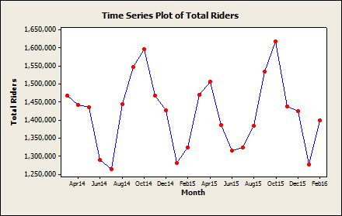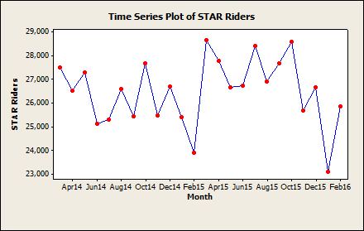
Previous: 1,325,031
1,429,330

Current: 1,399,388

Previous: 23,917

Current: 25,866

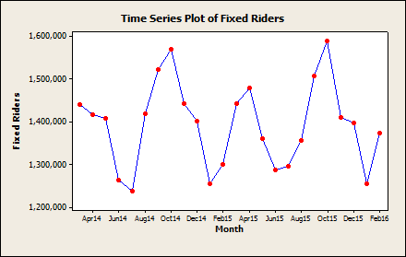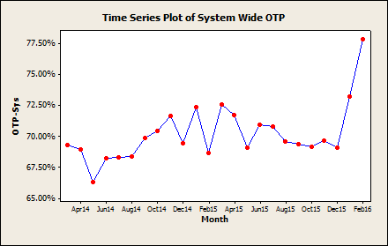
Previous: 1,301,114

Current: 1,373,522

Previous: 68.71%

Current: 77.88%

Reliability

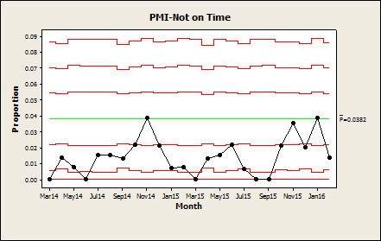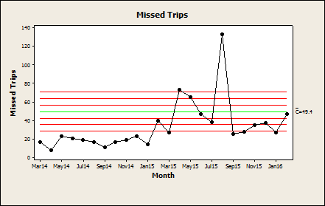
Previous: 0.78%

Current: 1.40%

Previous: 40

Current: 47

1

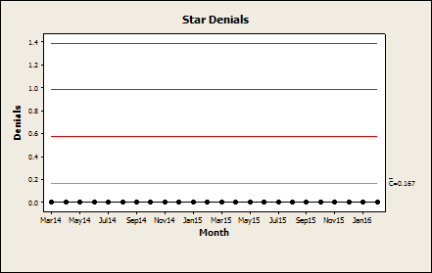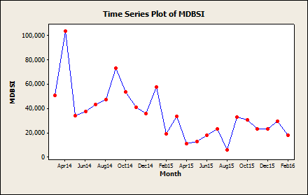
Previous: 0
Current: 0
Previous: 19,092

Current: 18,072

Safety

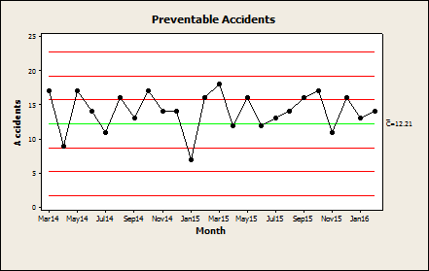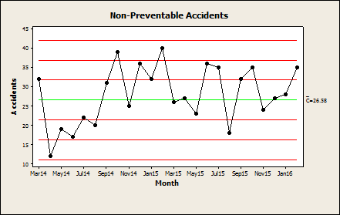
Previous: 16

Current: 14

Previous: 40

Current: 35

Customer Service

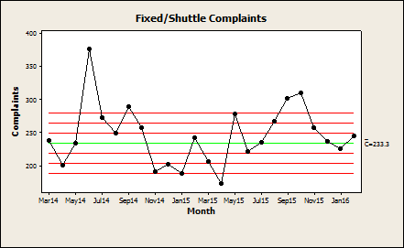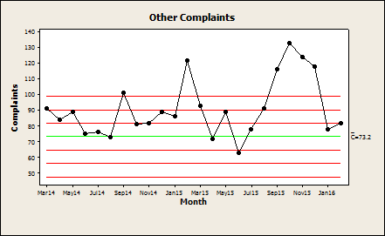
Previous: 242

Current: 245

Previous: 122

Current: 82

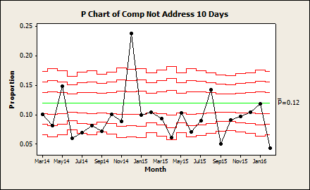
Previous: 10%

Current: 4%

Monthly Performance Report Notes

Additional Definitions
Passenger Boardings – Fixed Route – Includes fixed route, NX, cash fare, swiper, day cards, 1&10 ride tickets, contracts, employees, and special events/trolley.
Passenger Boardings – STAR – Route 93
Total Passenger Boardings – Includes fixed route, NX, cash fare, swiper, day cards, tokens, 1&10 ride tickets, contacts, employees, special events/trolley, and STAR.
On Time Performance (OTP) % -- The percentage of departures that occurred between 5 minutes late and 1 minute early. Departures more than 30 minutes late or more than 15 minutes early are excluded. This is calculated across all times points in all routes in the system.
Ridership per Revenue Hour – The total passenger boardings (not including STAR) divided by total revenue hours scheduled (also not including STAR). Revenue hours scheduled comes from fixed route scheduling system (Hastus).
Total Trips Scheduled – Comes from fixed route scheduling system. Includes Fixed, Shuttle, NX, & Rural. (Hatsus).
Missed Trips – Collected by dispatchers and aggregated by administration.
STAR Capacity Denials – The number of trips unavailable one hour before or one hour after requested trip time, due to capacity constraints. Customer refusals are not included in this measure. Customer refusals are defined as when customers are provided with five alternative trip times all of which the customer denies.
STAR On-Time Performance – The number of trips when arrival is between 0 and 25 minutes after time of scheduled arrival. This figure does not represent taxi rides, only CDTA operated vehicles.
Miles Operated – Total miles operated (including stubs, deadheads, trips to external garages for service, etc.). – Essentially every mile the bus travelled for any reason, according to odometers.
Revenue Miles Operated – Scheduled miles only (not adjusted), including fixed route, NX, and STAR bus and STAR taxi.
Mean Dist. Between Service Interrupt. – Total Miles Operated divided by number of service interruptions. A service interruption is defined as Incident, accident, operator running late, traffic delays, tire issues, etc., causing a service interruption (delay) of 5 minutes or more.
Preventative Maintenance Schedule – Number of Preventative Maintenance (PM) work orders completed within 500 miles before and 500 miles after the scheduled mileage, divided by the number of PM’s done for the month.
Preventable Accidents – The number of accidents safety determines that the operator failed to initiate a defensive driving action that may have prevented to reduce the severity of the accident.
Non-Preventable Accidents – The number of accidents safety determines that the operator did not fail to initiate a defensive driving action that may have prevented to reduce the severity of the accident.
Complaint – All route complaints minus compliments (customer information, employee, equipment, service and other), non-route complaints (buildings, fare collection, technology and other), requests (mailings, new bus stop, removal of a bus stop, new shelter, removal of a shelter, new service, expanded service) and complaints on complaints. Complaint must be “in progress” or “addressed”. Complaint categorizations may experience minor fluctuations after the fact for the prior month (after this report is generated).

