CDTA COMMITTEE AGENDA

Governance Committee

Thursday, February 16, 2017

Start Time - 11:30 am; Anticipated End Time – 12:00 pm
CDTA Board Room – 110 Watervliet Avenue

Committee Item Responsibility
Call to Order Dave Stackrow

Ascertain Quorum

Agenda Approval Dave Stackrow

Approve Minutes of December 8, 2016 Dave Stackrow

Consent Agenda Items
None

Administrative Discussion Items
- Legislative Update Lisa Marrello

Governance/Policy Issue Discussion Items
None

Executive Session
None Dave Stackrow

For the Good of the Order Dave Stackrow

Next Meeting Date: March 23, 2017

Adjourn

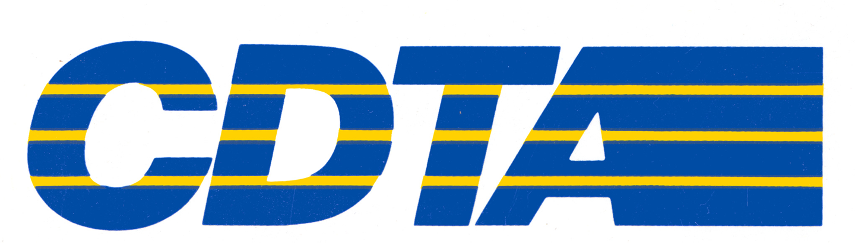

Capital District Transportation Authority
Governance Committee
Meeting Minutes – December 8, 2016 at 11:30 am; 110 Watervliet Avenue

In Attendance: Georgie Lussier (Acting Chair), Art Young, Denise Figueroa, Norm Miller,
Mark Schaeffer, Carm Basile, Amanda Avery, Mike Collins, Chris Desany, Fred Gilliam,
Lance Zarcone, Phil Parella, Jaime Watson, Kathy Colbert

Meeting Purpose
This was the regular monthly meeting of the Governance Committee. Ms. Lussier noted that a quorum was present. Minutes from the October 20, 2016 meeting were reviewed and approved.

Consent Agenda Items
None

Administrative Discussion Items
Legislative Update – Lisa Marrello
Lisa Marrello provided an update on lobbying activities. She discussed post-election results and, although there are two races in recount, the Republican Party will maintain control of the Senate. She advised that Jeff Klein and members of the Independent Democratic Conference (IDC) will likely side with the Republicans on issues.

Lisa advised that Governor Cuomo will deliver his State of the State Address, along with his executive budget, on January 11, 2017.

Lisa talked about a bill that was considered in the House and Senate to initiate a Ridesharing outside New York City. The bill, which would expand ride sharing to Upstate New York did not pass (there were disagreements over insurance and necessary protections for drivers and passengers). Lisa said lawmakers are confident the differences can be worked out this year.

Lisa advised that the Governor’s budget included legislation to reform the Workers Compensation program; the Assembly dismissed the proposal and it’s off the table for now.

Executive Session
None

For the Good of the Order
Georgie advised that there was a headline in the news about the Uncle Sam Transit Center in Troy. She said this project has been carefully planned and is discussed regularly as part of the Board’s agenda. Carm advised that the project is minimally delayed because it is taking longer than anticipated to negotiate with the owner of the property.

Adjournment and Next Meeting
The next meeting of the Committee, which is subject to the call of the Committee chairperson, is scheduled for January 19, 2016 at 11:30 am at 110 Watervliet Avenue.

Respectfully submitted by Carm Basile: _______________________________________

