CDTA COMMITTEE AGENDA

Planning and Stakeholder Relations Committee

Thursday, January 25, 2018

Start Time - 12:00 PM; Anticipated End Time – 1:15 PM
110 Watervliet Avenue

Committee Item Responsibility
Call to Order Joe Spairana

Ascertain Quorum Joe Spairana

Agenda Approval Joe Spairana

Approve Minutes of December 7, 2017 Joe Spairana

Consent Agenda Items
- Approve Taxi MOU’s with Local Municipalities Lauren Bailey

Administrative Discussion Items
- FY2019 Budget Development* Mike Collins
- Potential 2018 Service & Project Considerations* Ross Farrell
- Uncle Sam Update Chris Desany
- Navigator Update Jon Scherzer

Governance/Policy Issue Discussion Items

Executive Session
None

Next Meeting Date: February 22, 2018

Adjourn

* Indicates Material (Or Additional Material) Will Be Provided at Meeting

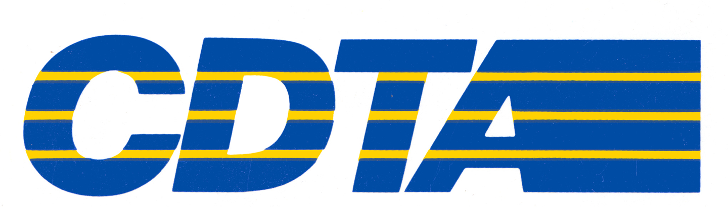

Capital District Transportation Authority
Planning and Stakeholder Relations Committee
Meeting Minutes – December 7, 2017 at Noon at the 110 Watervliet Avenue Office

In Attendance: Joe Spairana (Chair), Mike Criscione, Jayme Lahut, Mark Schaeffer, Corey Bixby, Carm Basile, (CEO), Mike Collins, (CSL), Chris Desany, Amanda Avery, Jaime Watson, Sarah Matrose, Lance Zarcone,
Phil Parella, Fred Gilliam, Ross Farrell, Kelli Schreivogl, Thomas Guggisberg, Jonathan Scherzer

Meeting Purpose
This was the regular monthly meeting of the Planning Committee.

Consent Agenda Items
Preliminary Budget Approval for FY2019 – Mike Collins
Mike Collins presented a preliminary budget forecast for Fiscal Year 2019. New York State requires that we submit a board approved forecast by the end of the year.

This budget forecast is the starting point for development of our operating plan, and it includes several broad assumptions. We expect our operating needs to be at least $87 million, a 3% increase from this year. We have some unknowns right now that include state operating assistance and federal maintenance. We will not know what our state operating assistance will be until late January when the Governor’s budget is released.

We will continue legislative visits with our advocacy team. These visits will be in full swing starting in January.

Over the next few months, the Committee will provide options as the budget development process continues.

The Committee recommends approving the preliminary budget for fiscal year 2019 to meet New York State requirements.

Approval & Findings of Eminent Domain Hearing - Chris Desany
Chris Desany provided the determination and findings of the land acquisition process for the Uncle Sam Transit Center. The public hearing was held on November 16 at Troy City Hall. Six members of the public attended and three spoke. Some issues were raised about the engineering of the structures, costs, and traffic control. All comments were collected, and the transcript is available for anyone who would like it.

The Committee recommends approving the land acquisition public hearing determination and findings for the Uncle Sam Transit Center.

Administrative Discussion Items
Navigator Transition - Jonathan Scherzer
Jonathan Scherzer provided the final transition timeline for Navigator.

Full transition to Navigator smartcard and mobile ticketing will be complete by December 31, and we are conducting an extensive outreach campaign to our customers. The Committee had a good discussion about different ways to reach our customers.

Important dates include:

- December 31, 2017: Sale of magnetic-striped fare media, day passes and change cards will be discontinued.

- January 1, 2018: Customers will put fare products on a Navigator smartcard or mobile ticket application.

- March 31, 2018: Will be the last day that CDTA will accept magnetic-striped fare products on buses.
CDPHP Cycle! Year-End Summary – Jonathan Scherzer
Jonathan Scherzer provided a report on the bikeshare program. CDPHP Cycle! launched on July 27, with 160 bicycles and 40 stations. It has been a huge success. CDPHP is the Authority’s title sponsor.

11,500 trips were taken, and nearly 2,500 members joined this exciting new program. The most popular bike hubs were at Hudson River Park, Madison & Lark, and Saratoga State Park. Next year, we will expand to 320 bikes with more infrastructure capacity. We will build on our success, grow our partnership base, and integrate our Navigator card into the process.

For the Good of the Order
None

Action Items
None

Adjournment and Next Meeting
The next meeting of the Committee will be held at noon on January 25, 2018 at 110 Watervliet Avenue.

Respectfully submitted by Michael P. Collins:

_______________________________________

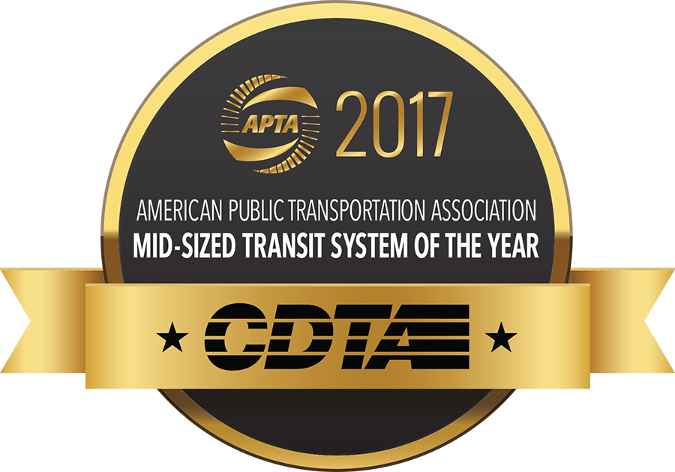
Memorandum

January 18, 2018

To: Carm Basile, Chief Executive Officer

From: Jonathan Scherzer, Director of Marketing

Subject: Taxicab Regulatory Oversight

Background
In 2016, CDTA was granted oversight of Capital Region taxicabs to create a common ordinance with consistent rules for appropriate municipalities to adopt. Once a municipality passes the ordinance, they are eligible for CDTA to assist with their taxi program. We have seen progress with the opening of customer service channels along with the creation and adoption of the ordinance by three municipalities: the cities of Albany, Saratoga Springs and Troy. Schenectady recently held a public hearing and we are still working with Rensselaer and Colonie on passage.

Current Activities
For CDTA to assist municipalities with their taxi programs, a municipality must first adopt the Common Ordinance to streamline regulations, and then enter into a Memo of Understanding with CDTA. An MOU between CDTA and a municipality includes responsibilities of each party as well as termination and indemnification language. All MOUs must be approved by the CDTA Board of Directors before CDTA is able to begin assisting the municipality.

Each MOU can be unique to the municipality, and will focus on the best approach for CDTA to perform administrative duties relating to applications for, and issuance of, Taxicab Medallions, Taxicab Owners’ Licenses and Taxicab Drivers’ Licenses. Once two municipalities sign MOUs with CDTA, we will begin providing support services and identify appropriate staff liaisons.

For January 2018, we have finalized MOUs with the Cities of Saratoga Springs and Troy for the CDTA Board of Directors to approve.

Next Steps
We will formalize the complaint process as ordinances get adopted so we can handle calls from customers, drivers, and owners. Forms and applications for Hack Licenses, Owners Licenses, and Medallions will be available on the CDTA website along with other resources as needed. We have discussed a grace period for the taxi companies so that they have appropriate time to procure new items and update their businesses where needed. We are determining best day-to-day contacts at each municipality given the changes and creating processes to streamline implementation. We will formalize issuance of licenses along with inclusion of currently-licensed drivers and owners in the LENS program, which tracks driver license record and confirming the process for fingerprinting and background checks.
Memorandum
January 17, 2018

To: Carm Basile, Chief Executive Officer

From: Jonathan Scherzer, Director of Marketing

Subject: CDTA’s Navigator Transition

Background
We have made the full transition to Navigator smartcard and mobile ticketing platform, which included discontinuation of the sale of magnetic-striped fare media and on vehicle pass purchases. The transition officially took place on January 1, 2018, while customers can use their old passes through March 31, 2018. Navigator fare products are now available at nearly 50 retail locations across the Capital Region.

This was supported by an education and outreach campaign that was conducted internally and externally. One key was insuring operators were informed and had the cards at their disposal, so training sessions were held and cards were distributed to each division along with brochures and frequently asked question pocket cards. Our travel trainers spent most of December onboard regular route and NX services meeting with customers and distributing cards.

Moving Forward
The transition has gone well with most customers receiving quality customer service coupled with easy access to either a Navigator smart card or mobile ticketing. We are being proactive to insure customer questions are being addressed in a timely manner. We will discuss some of the key topics driving the program at the committee meeting. This includes the exchange policy to convert leftover magnetic striped media, insuring customers understand the timeline for when funds become available on their card, and recent progress with third party partners to finalize their pass needs by audience.

By the Numbers
The official rollout of the program saw significant increases in the amount of cards, ridership and funds associated with Navigator. We registered roughly 4,500 customers in the past 45 days and overall, more than 15,000 customers have become registered Navigator users. There are also close to 25,000 active cards in use throughout the region accounting for nearly 300,000 rides in the past month.

