CDTA COMMITTEE AGENDA

Planning and Stakeholder Relations Committee

Thursday, October 19, 2017

Start Time - 12:00 PM; Anticipated End Time – 1:15 PM
110 Watervliet Avenue

Committee Item Responsibility
Call to Order Joe Spairana

Ascertain Quorum Joe Spairana

Agenda Approval Joe Spairana

Approve Minutes of September 21, 2017 Joe Spairana

Consent Agenda Items
- None

Administrative Discussion Items
- FY2018 Mid-Year Budget Review* Mike Collins
- Uncle Sam Property Acquisition Chris Desany
- Veteran’s Half Fare Program Jon Scherzer

Governance/Policy Issue Discussion Items

Executive Session
None

Next Meeting Date(s): Board Retreat on November 8, 2017
December 7, 2017 (Tentative)

Adjourn

* Indicates Material (Or Additional Material) Will Be Provided at Meeting

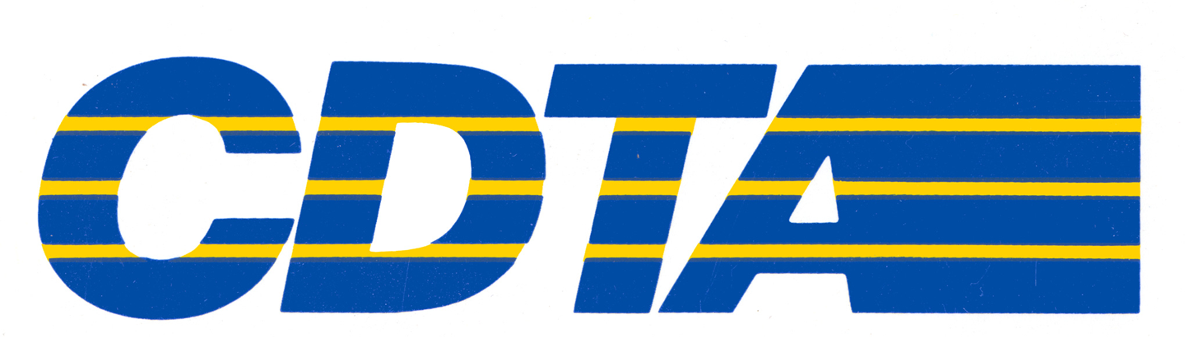

Capital District Transportation Authority
Planning and Stakeholder Relations Committee
Meeting Minutes – September 21, 2017 at Noon at the 110 Watervliet Avenue Office

In Attendance: Joe Spairana (Chair), Dave Stackrow, Georgie Nugent, Corey Bixby, Carm Basile (CEO), Mike Collins, (CSL), Chris Desany, Amanda Avery, Jaime Watson, Lance Zarcone, Phil Parella,
Jonathan Scherzer, Ross Farrell, Kathy Colbert

Meeting Purpose
This was the regular monthly meeting of the Planning Committee.

Consent Agenda Items
Cycle! Program Update - Jonathan Scherzer
Jonathan Scherzer provided an update on Bike Share, which we call CDPHPCycle. Bike Share started on July 27, 2017 with 40 stations and 160 bicycles located throughout 4 counties. Through this past weekend, almost 7,000 rides have been taken, and more than 1,800 members have signed up.

Some interesting notes:
- Bikes are used more on weekends
- The average bike is rented for 24 minutes.
- The bikes have been ridden a total of 18,000 miles

Next steps for us are:
- Expanding to 320 bikes in April 2018
- Increasing the number of docking stations
- Integrating our Navigator card access

Taxicab Update - Jonathan Scherzer
Jonathan Scherzer provided an update on Taxicabs and reviewed the goals, which include establishing regional rules and expectations for taxi providers. We will implement a regional fare structure and require meters in all cabs. We will also centralize requirements for vehicles and drivers and require credit card readers in all cabs. The new ordinance should be in place by January 1, 2018.

Capital Projects Report -Ross Farrell
Ross Farrell provided the Capital Projects Report which was included in the members’ packets.

For the Good of the Order
None

Action Items
None
Adjournment and Next Meeting
The next meeting of the Committee will be at noon on Thursday, October 19, 2017 at
110 Watervliet Avenue.

Respectfully submitted by Michael P. Collins:

_______________________________________

To: Chairman, Planning and Stakeholder Relations Committee
Committee Members
From: Christopher Desany, Vice President of Planning and Infrastructure
Date: October 19, 2017
Re: Notice of Land Acquisition Hearing for Eminent Domain Proceedings

Background
The River Corridor Bus Rapid Transit (BRT) consists of a 16-mile corridor with 31 stations that will provide faster, more direct, more frequent and more reliable north-south service along the Hudson river. It will start from two branches (Cohoes and Waterford) that would meet in Lansingburgh and travel through downtown Troy, Watervliet, Menands, and downtown Albany before branching again to terminate at Second and Delaware Avenues and Old South Pearl Street in South Albany. It serves major employment sites, activity centers, a growing residential population, and areas of significant proposed development. As discussed last month, the Federal Small Starts program application for this project was resubmitted to the FTA in early September.

Projects of this nature involve positioning stations at various locations across the corridor. To build the BRT, CDTA needs to acquire property rights for any parcels that fall outside the highway right of way, and to do so, a very specific process must be followed. In the case of the Uncle Sam Transit Center, where negotiations in good faith are no longer productive, we are proceeding with the eminent domain procedure. We must perform a detailed appraisal and formally provide an offer for the fair market value of the land. Most of these regulations are found in the Uniform Relocation Assistance and Real Property Acquisition Policies Act of 1970 (Uniform Act).

One of the other steps in the process requires us to hold public hearing(s) to give people the opportunity to hear about the real estate and eminent domain specific aspects of the project, and afford the public an opportunity to comment. To advertise and hold these hearing(s) requires Board approval. With the exception of the Uncle Sam Transit Center, this step was completed last year for all the stations along the River Corridor. We are now looking to complete this process for Uncle Sam and move forward with acquiring the land.

Proposed Action
Staff recommends that the Committee advance the proposed Uncle Sam land acquisition public hearing schedule to the full Board for endorsement.

Hearing Location | Date/Time
Rensselaer County
Troy City Hall, 5th Floor  433 River Street, Troy, NY 12180 | November 16, 2017 (6p-8p)

Upcoming Schedule
Date | Activity
November 2017 | Hold Hearing
December 2017 | Publish Determination and Findings
January 2018 | Prepare and Submit Eminent Domain Procedure Law Petition
March 2018 | File Maps with County Clerk
March 2018 | Begin Uncle Sam Construction
November 2018 | Complete Uncle Sam Construction

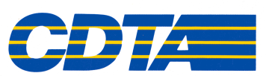

Memorandum

October 13, 2017

To: Carm Basile, Chief Executive Officer

From: Jonathan Scherzer, Director of Marketing

Subject: Half Fare Veterans Program

Background
CDTA provides reduced fare pricing to qualified Veterans that receive disability benefits. Veterans can display their Medicare card or a Disabled Veterans ID card to take advantage of this program. Staff has developed a program to expand access to the CDTA route network for a broader group of veterans that have served our country honorably.

Concept
We contacted the New York State Division of Veterans’ Affairs, which supports the concept to provide half fare benefits across the Veterans community. We have identified roughly 60,000 veterans that have been honorably discharged in our service area. Half fare pricing for veterans would provide an additional benefit, highlight CDTA’s progressiveness and offer a real-world solution of more mobility choices for those who have served our country.

The benefit should result in more ridership, better support for the region’s economy, while not hurting CDTA’s financial position. Navigator allows us to include a photograph and Veteran marking on the back to insure vetting of potential fraud scenarios, as well as having the ability to report the number of Veterans using our services.

Next Steps
We propose that all honorably discharged veterans living in CDTA’s four county service area be afforded half fare pricing. We do not have data on current levels of Veteran ridership, making projections challenging. We will coordinate with area agencies to identify candidates and each county agency has agreed to support the program with mailings, website listings, outreach and marketing materials. We will coordinate face-to-face information sessions with our Travel Trainers and create Navigator ID cards to formalize participation.

We would accept one of the four proof of discharge documents available to verify they were discharged under honorable conditions. Veterans will be able to visit any half fare issuing site in the Capital Region to get their Navigator ID card. We will partner with the Agencies to assist with paperwork and photographs to streamline administration. Once certified for their Navigator card, veterans will be identified as program members. The program announcement will be supported by media outreach and public education.

